Extending a Quantitative Approach to Tactical Asset Allocation in South Africa

INSEAD Masters in Finance (MFIN17M) – Capstone Project

**Cameron Allan McLean**  
cameron.mclean@insead.edu

April 2017

Contents

List of Figures 3

List of Tables 4

Introduction 5

Replication of A Quantitative Approach to Tactical Asset Allocation 6

Summary of A Quantitative Approach to Tactical Asset Allocation 6

Data used 6

Strategy Performance Metrics 7

Asset Returns 1973-2016 9

A Global Tactical Asset Allocation 1973-2016 10

Analysis of Performance 15

Diversification and Modern Portfolio Theory 15

Recent Performance and the Financialisation of Commodities 16

Performance under rising interest rates 21

Behavioural implications for Trend Following Investors 24

Improving returns 26

Asset Allocation Diversification 26

Alternative Trend Following Strategies - Avoiding Whipsaws 27

Delayed entry 28

Timing Envelopes 30

Diversification of trading strategies and parameters 32

A Quantitative Approach to Tactical Asset Allocation in South Africa 35

Data Used 35

South African Asset Class Returns excluding Real Estate (1971-2016) 36

Timing Strategy Performance 37

JALSH – South African Domestic Equities 38

MSCIWORLD – Foreign Developed Equities (in ZAR) 39

SA10YR – Fixed Income 40

GSCI – Commodities (in ZAR) 41

Systematic Tactical Asset Allocation South Africa (1972-2016) 42

South African Asset Class Returns including Real Estate (1993-2016) 43

JSAPY – South African Real Estate 44

Systematic Tactical Asset Allocation South Africa including Real Estate (1994-2016) 45

Comparison to South African funds 46

Conclusion 49

Appendix – Review of R 51

References 52

# List of Figures

Figure 1 - Asset Class Returns 1973-2016, Log Scale 9

Figure 2 - Asset Class Returns 2013-2016, Non-Log Scale 9

Figure 3 - Buy and Hold vs. Timing Model 1973-2016, Log scale 11

Figure 4 - Buy and Hold vs. Timing Model 1973-2016, Non-log scale 11

Figure 6 - Buy and Hold vs. Timing Model 2006-2016, non-log scale 12

Figure 7 - Buy and Hold vs. Timing Model Drawdowns, 2006-2016 13

Figure 8 - Rolling 12-month Annualised Returns 2006-2016 13

Figure 9 - Asset Class Returns 2006-2016 17

Figure 10 – 36 month Rolling Correlations with GSCI, 1973-2016 18

Figure 11 - US 10 Year Constant Maturity Yields 21

Figure 12 - US10YR Total Returns, Log Scale 21

Figure 13 - Asset Class Returns 1973-1981, Non log scale 22

Figure 14 - Performance under rising rates 1973-1981 23

Figure 15 - Drawdowns under rising rates 1973-1981 23

Figure 16 - Timing Tracking Error to B&H 12-month Rolling Annualised Returns 26

Figure 17 - SP500 Price vs 10m Simple Moving Average 1977-1978 29

Figure 18 - SP500 Delayed Timing Performance During Whipsaws 1977-1978 29

Figure 19 - Trading Envelope Price Chart 1977-1978 31

Figure 20 - Trading Envelope Performance During Whipsaws 1977-1978 31

Figure 21 - Buy and Hold vs Timing vs Multi Strat Performance 1973-2016 33

Figure 22 - Buy & Hold vs Timing vs Multi Strategy Drawdowns 1973-2016 33

Figure 23 - South Africa Asset Class Returns 1972-2016, Log Scale 36

Figure 24 - JALSH Strategy Returns 1972-2016, Log Scale 38

Figure 25 - JALSH Strategy Drawdowns 1972-2016, Non-log scale 38

Figure 26 – MSCIWORLD (ZAR) Strategy Returns 1972-2016, Log Scale 39

Figure 27 – MSCIWORLD (ZAR) Strategy Drawdowns 1972-2016, Non-log scale 39

Figure 28 – SA10YR Strategy Returns 1972-2016, Log Scale 40

Figure 29 – SA10YR Strategy Drawdowns 1972-2016, Non-log scale 40

Figure 30 – GSCI (ZAR) Strategy Returns 1972-2016, Log Scale 41

Figure 31 – GSCI (ZAR) Strategy Drawdowns 1972-2016, Non-log scale 41

Figure 32 – Systematic Tactical Asset Allocation Strategy Returns 1972-2016, Log Scale 42

Figure 33 – Systematic Tactical Asset Allocation Strategy Drawdowns 1972-2016, Non-log scale 42

Figure 34 - South African Asset Class Returns 1993-2016, Log scale 43

Figure 35 – JSAPY Strategy Returns 1994-2016, Log Scale 44

Figure 36 – JSAPY Strategy Drawdowns 1994-2016, Non-log scale 44

Figure 37 – Systematic Tactical Asset Allocation Strategy Returns 1994-2016, Log Scale 45

Figure 38 – Systematic Tactical Asset Allocation Strategy Drawdowns 1994-2016, Non-log scale 45

Figure 39 - Fund Comparison Strategy Returns 2004-2016 47

# List of Tables

Table 1 - Data Sources 7

Table 2 - Performance Metrics 7

Table 3 - Asset Class Returns 1973-2012 10

Table 4 - Asset Class Returns 1973-2016 10

Table 5 - Percentage of Time Invested 1973-2016 10

Table 6 - Summary of Returns for Buy and Hold vs Timing Model 12

Table 7 – Performance with and without commodities 2006-2016 17

Table 8 – Performance with and without commodities 1973-2006 18

Table 9 - Asset Class Returns 1973-1981 22

Table 10 – Performance under rising rates 1973-1981 23

Table 11 - Delayed Entry Strategy Performance 1973-2016 28

Table 12 - Delayed Timing Performance 1977-1978 29

Table 13 - Timing Envelope Strategy Performance 1973-2016 30

Table 14 - Timing Envelope Strategy Performance 1977-1978 31

Table 15 - Multiple Time Frame Performance 1973-2016 32

Table 16 - Multi Strategy Performance 1973-2016 34

Table 17 - Data Sources for South Africa 36

Table 18 -South Africa Asset Class Returns 1972-2016 37

Table 19 - JALSH Strategy Performance Metrics 1972-2016 38

Table 20 – MSCIWORLD (ZAR) Strategy Performance Metrics 1972-2016 39

Table 21 – SA10YR Strategy Performance Metrics 1972-2016 40

Table 22 – GSCI (ZAR) Strategy Performance Metrics 1972-2016 41

Table 23 – Systematic Tactical Asset Allocation Strategy Performance Metrics 1972-2016 42

Table 24 - South African Asset Class Returns 1993-2016 43

Table 25 – JSAPY Strategy Performance Metrics 1994-2016 44

Table 26 – Systematic Tactical Asset Allocation Strategy Performance Metrics 1994-2016 45

Table 27 - Fund Comparison Strategy Returns (0% fees) 47

Table 28 - Fund Comparison Strategy Returns (1%. fees) 2004-2016 48

# Introduction

In 2006 Mebane Faber released a series of papers titled “A Quantitative Approach to Tactical Asset Allocation” which have since become the most downloaded and read papers on SSRN. In this paper I replicate and update Faber’s strategy with updated data from 2013-2016 and analyse the latest performance. I then identify important behavioural implications for investors following the strategy and keeping these in mind look at ways to improve the core timing model’s performance. Lastly I apply the original timing strategy and improved timing strategies to an asset allocation more relevant for an investor in South Africa.

Overall I find that the timing model consistently delivers superior risk adjusted performance over long time horizons when applied to a variety of different asset classes. When applied to a portfolio of assets, the timing model continues to deliver strong positive returns since 2006, although at lower absolute levels than previous periods. The value in the timing model is avoiding volatility and long periods of drawdowns and the strategy worked perfectly in the recent 2007/2008 global financial crisis as it protected the portfolio from significant drawdowns that eroded multiple years of gains for the equivalent buy and hold portfolio.

I find the two main drivers of the timing model’s performance are diversification and employing a commonly used trend following timing strategy. Improving the original timing model is explored in three ways; increasing asset diversification, using alternative trend following strategies and then employing multiple strategies at once to gain the benefits of strategy diversification. All give investors practical ways to manage downside risk and obtain improved risk adjusted performance with reduced drawdowns.

Applying the quantitative approach to an asset allocation more relevant for a South African investor delivers consistent results. Although Faber’s timing model delivers similar outperformance on the whole, in some cases it is subject to whipsaws. These whipsaws deteriorate some of the absolute performance and in one asset class’s case, results in a higher maximum drawdown than the buy and hold portfolio. The value of the improved timing strategies is clearly demonstrated over these assets as they deliver improved risk adjusted performance that would be attractive for a risk and loss adverse investor.

# Replication of A Quantitative Approach to Tactical Asset Allocation

## Summary of A Quantitative Approach to Tactical Asset Allocation

In July 2006, Mebane Faber began to circulate a working paper entitled A Quantitative Approach to Tactical Asset Allocation which was subsequently published by The Journal of Wealth Management in Spring 2007. In February 2009 Faber updated his paper to include data from 2006-2008 and then again updated the paper in February 2013 to include data from 2009-2012 as well as test the approach on alternative asset classes and allocations.

The purpose of the paper was “to present a simple quantitative method that improves risk adjusted returns across various asset classes” (Faber M. , 2013). Testing over five asset classes from 1973-2012, his approach improved risk adjusted returns in every asset class tested and when applied to asset allocation, resulted in a portfolio that exhibited equity like returns with bond like volatility and drawdowns.

The quantitative approach proposed by Faber market times entries and exits into positions using a common trend following simple moving average based system. The entry and exit rules were simple; buy when the price was greater than the simple moving average and sell and move to cash when the price crossed below the simple moving average. Using monthly data, Faber chose the 10-month averaging period for his system however showed parameter stability of using various moving average periods ranging from 3 to 12 months. Overall this system met his criteria of being “simple enough for investors to follow, and mechanical enough to remove emotion and subjective decision-making” (Faber M. , 2013).

Applying the timing system to individual asset classes consistently resulted in improved absolute returns, risk adjusted returns and max drawdowns. On average between 1973-2008 the timing system “increased returns by approximately 20%, decreased volatility by 20%, improved the Sharpe Ratio by 0.20 and reduced the maximum drawdown by nearly 50%” (Faber M. , 2009).

The timing system was then applied to an asset allocation that was equal weighted five asset classes. Comparing to a buy and hold portfolio, the timing system improved various performance and risk metrics. Between 1973-2012, the timing system produced better returns of 10.48% (vs 9.92% for the buy and hold) and lower volatility of 6.99% (vs 10.28%) resulting in an improved Sharpe ratio of 0.73 (vs 0.43). Critically for drawdown adverse investors, the maximum drawdown of the timing system model was only -9.54% (vs -46.00%) meaning that investors in the strategy never experienced the pain of giving back more than 10% despite multiple financial crashes. Remarkably in the 40 years of data between 1973-2012, the timing strategy only had 1 year of negative performance which was a very reasonable -0.59%.

## Data used

Faber applied his quantitative approach to five asset classes – Domestic (US Large Cap) Equities, Foreign Developed Equities, US Bonds, Commodities and Real Estate. He chose publicly traded indices representing these asset classes and obtained monthly total return data series from Global Financial Data to use in his framework. The actual indices chosen were Standard and Poor’s 500 Index (S&P 500), Morgan Stanley Capital International Developed Markets Index (MSCI EAFE), United States Government 10yr Treasure Bonds (US10YR), Goldman Sachs Commodity Index (GSCI) and the National Association of Real Estate Investment Trusts Index (NAREIT).

Global Financial Data is a paid data provider unwilling to make their data available for academic purposes and alternative data used in this paper has been obtained from a variety of sources. S&P500, NAREIT, EAFE, GSCI total return index data were available on Bloomberg. To represent Fixed Income, 10-year US Government Bond Yields were obtained from the Federal Reserve Economic Data (FRED) database maintained by the Federal Reserve Bank of St. Louis and a total return index that takes into consideration both capital appreciation and income return has been created following a methodology paper from Morningstar (2008). A similar index to represent risk free returns was created using 3-month US Treasury Bill yields. Replicate Faber’s results between 1973-2012 using this data resulted in minimal differences giving confidence that the alternative dataset is close enough to the original GFD data that it can be used and its results are representative.

Table 1 - Data Sources

|  |  |
| --- | --- |
| **Asset Class** | **Source** |
| Domestic Equities | 1972-2016: S&P 500 Total Return Index (Bloomberg - SPTR2 Index) |
| Foreign Equities | 1972-2016: MSCI EAFE Total Return Index (Bloomberg - GDDUEAFE Index) |
| Fixed Income | 1972-2016: Total return index created using 10-Year Treasury Constant Maturity Rates (FRED – DGS10) |
| Commodities | 1972-2016: S&P GSCI Total Return Index (Bloomberg - SPGSCITR Index) |
| Property | 1972-2016: FTSE NAREIT Composite Real Estate Total Return Index (Bloomberg - FNCOTR Index) |
| Inflation | 1972-2016: U.S. Bureau of Labor Statistics Consumer Price Index for All Urban Consumers: All Items (FRED – CPIAUCSL) |
| Risk Free | 1972-2016: Risk free / Cash index created using 3-Month Treasury Bill: Secondary Market Rates (FRED – DTB3) |

## Strategy Performance Metrics

A trading strategy’s performance is commonly analysed and judged by inspecting its returns that have been somewhat adjusted for risk. Simply looking at the return would be unfair (Ilmanen, 2011) as it ignores the volatility of the strategy and whether it is something that can realistically be handled by the investor (Clenow A. , 2013). In Faber’s papers, he compares strategies by looking at the Compounded Annual Growth Rate (CAGR), Volatility, Sharpe Ratio, Max Drawdown and in some comparisons, he also includes the percentage of positive months as well as the growth of $100. Although the basic structure of all composite risk measures are the same, it is recommended that several better understood metrics are selected to give a fuller understanding of each strategy’s performance and risk (Bacon, 2004). In this paper the following metrics have been included to analyse performance:

Table 2 - Performance Metrics

|  |  |  |
| --- | --- | --- |
| CAGR | % in the Market | Max Drawdown / CAGR |
| Volatility | % Positive Months | Sharpe Ratio |
| Skew | Best Month | Sortino Ratio |
| Kurtosis | Worst Month | MAR Ratio |
| Inflation CAGR | Max Drawdown | Ulcer Index |

Different performance metrics provide alternative descriptive ways of viewing the performance of each strategy. The Sharpe Ratio is one of the most commonly used and cited measures to compare strategies of different volatility and was the only risk adjusted return metric included in Faber’s papers. Originally developed by William Sharpe in 1966, the formula is simply the annualised return less the risk free return divided by the volatility of the return. One of the problems with the Sharpe Ratio is that is penalises all volatility whereas in some cases, such as when the strategy is making money on the upside, the investor may actually like and desire volatility. With this in mind the Sortino Ratio has been included as it only adjusts using the volatility of negative returns and does not punish returns for moves in the right direction.

Volatility is one measure used by investors who are risk adverse but it is well known that investors can also be loss adverse. As such measures that risk adjust returns by the maximum drawdown have also been included such as the MAR ratio (or Calmar ratio). It is traditional to use 3 years for the Calmar ratio, however here the MAR ratio is used which looks at the whole time period. Max Drawdown / CAGR is a very similar metric that has also been included purely for its simplicity to illustrate to investors the magnitude of drawdowns as the time period required to recover based on average annual returns. Developed by Peter Martin in 1987 the Ulcer Index has also been included as another measure of downside risk. Suited for long only strategies, the ulcer index focuses on the length and severity of drawdowns and the worry caused to the investor – the higher a strategy’s Ulcer Index, the more likely it will cause sleepless nights or ulcers for the investor (Martin & McCann, 1989).

Lastly skew and kurtosis have been included to give a more complete understanding of the return distribution. Another problem with the Sharpe Ratio is that it fails to be useful over strategies that don’t have a normal distribution of returns. Many strategies, such as those that sell volatility, generate small positive returns with the occasional large negative return. Until a large loss occurs, they show very respectable Sharpe Ratios. As such the third and forth moment has been included to identify strategies that may have misleadingly high Sharpe Ratios.

## Asset Returns 1973-2016

Reviewing the performance of each asset class between 1973-2016 shows multi decade positive absolute returns for all classes. Faber (2013) charts asset class returns to see the routes they travelled from start to finish and visually comparing these charts to the replication supports earlier conclusions that the data used in this paper closely matches the original data provided by Global Financial Data.

Figure 1 - Asset Class Returns 1973-2016, Log Scale

Charting the performance of the most recent years since Faber’s last update in 2013, we can see how assets have performed since 2012. Most assets have continued to deliver positive returns over the period however commodities have significantly underperformed and continued to stay in drawdown since they reached all-time highs in 2008.

Figure 2 - Asset Class Returns 2013-2016, Non-Log Scale

Calculating the same performance statistics over these asset classes results in very similar results to Faber’s research, another confirmation that the data used in both pieces of research is close to identical and accurate enough for further extensions.

Table 3 - Asset Class Returns 1973-2012

|  |  |  |  |  |  |  |
| --- | --- | --- | --- | --- | --- | --- |
|  | TBILLS | SP500 | EAFE | US10YR | GSCI | NAREIT |
| Return | 5.42% | 9.77% | 9.19% | 8.12% | 8.34% | 9.64% |
| Volatility | 0.95% | 15.71% | 17.60% | 8.47% | 20.55% | 18.16% |
| Sharpe (5.42%) | 0.00 | 0.26 | 0.20 | 0.30 | 0.13 | 0.22 |
| MaxDD | 0.00% | -50.95% | -56.40% | -15.75% | -67.65% | -68.18% |
| Inflation CAGR | 4.33% | 4.33% | 4.33% | 4.33% | 4.33% | 4.33% |

Extending these performance statistics to include 2013-2016, the biggest change in performance for any asset class is as expected in commodities. From extending 40 years of data to include another 4 years, the current drawdown in commodities has resulted in a 30% reduction of the CAGR from 8.34% to 5.85%. The depth of the most recent drawdown was captured at 80.90% agreeing with Faber’s observation and warning that asset classes have in the past and are likely to have in the future periods where they decline 50-100%. Another interesting impact of the most recent data was its effect on SP500 performance. The current strong performance of the index testing all-time highs has resulted in a 0.40% increase in CAGR with a similar sized reduction in volatility, resulting in its Sharpe Ratio increasing 27% from 0.26 to 0.33.

Table 4 - Asset Class Returns 1973-2016

|  |  |  |  |  |  |  |
| --- | --- | --- | --- | --- | --- | --- |
|  | TBILLS | SP500 | EAFE | US10YR | GSCI | NAREIT |
| Return | 4.93% | 10.18% | 8.75% | 7.41% | 5.85% | 9.65% |
| Volatility | 1.00% | 15.30% | 17.21% | 8.33% | 20.52% | 17.81% |
| Sharpe (4.93%) | 0.00 | 0.33 | 0.21 | 0.28 | 0.04 | 0.25 |
| MaxDD | 0.00% | -50.95% | -56.40% | -15.75% | -80.90% | -68.18% |
| Inflation CAGR | 4.04% | 4.04% | 4.04% | 4.04% | 4.04% | 4.04% |

## A Global Tactical Asset Allocation 1973-2016

Replicating the timing strategy across all assets within the Global Tactical Asset Allocation model, we see that the percent of time invested including the most recent years has not changed significantly and is at 70.81%.

Table 5 - Percentage of Time Invested 1973-2016

|  |  |  |  |
| --- | --- | --- | --- |
| Number of Positions | % Invested | # of Months | % of Months |
| 0 (all cash) | 0% | 6 | 1.13% |
| 1 | 20% | 32 | 6.05% |
| 2 | 40% | 62 | 11.72% |
| 3 | 60% | 118 | 22.31% |
| 4 | 80% | 192 | 36.29% |
| 5 | 100% | 119 | 22.50% |
| TOTAL |  | 529 | 100.00% |

Figure 3 - Buy and Hold vs. Timing Model 1973-2016, Log scale

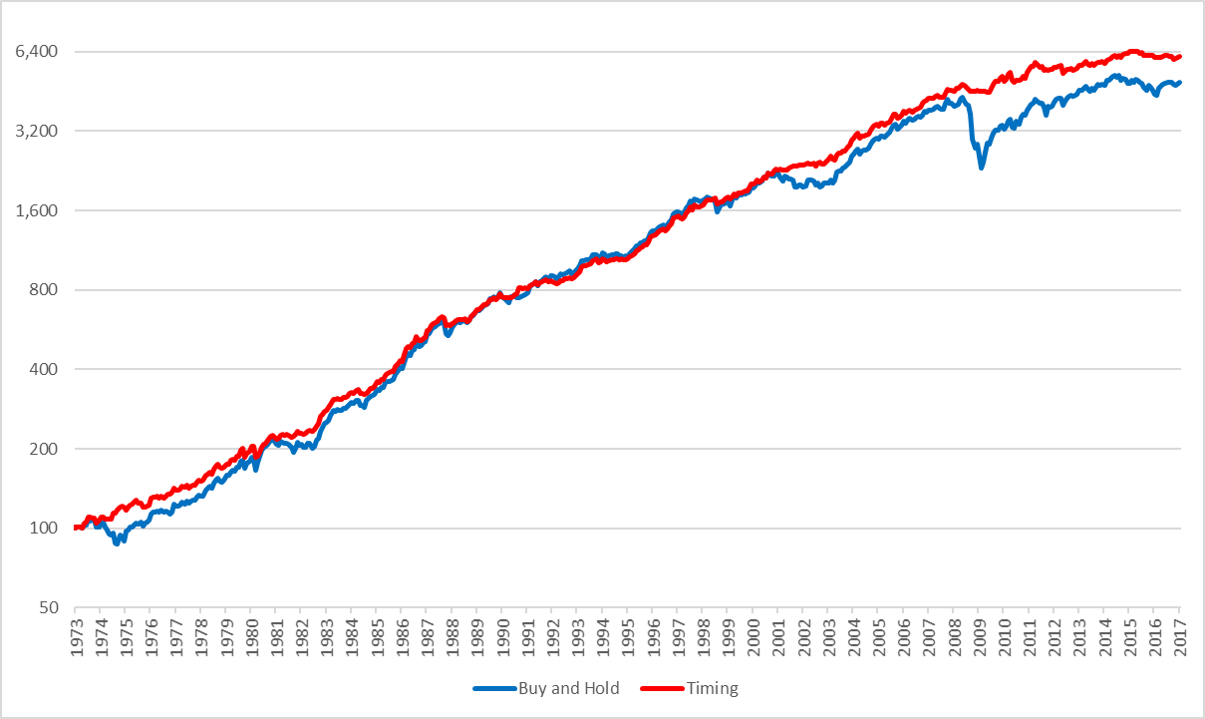

Figure 4 - Buy and Hold vs. Timing Model 1973-2016, Non-log scale

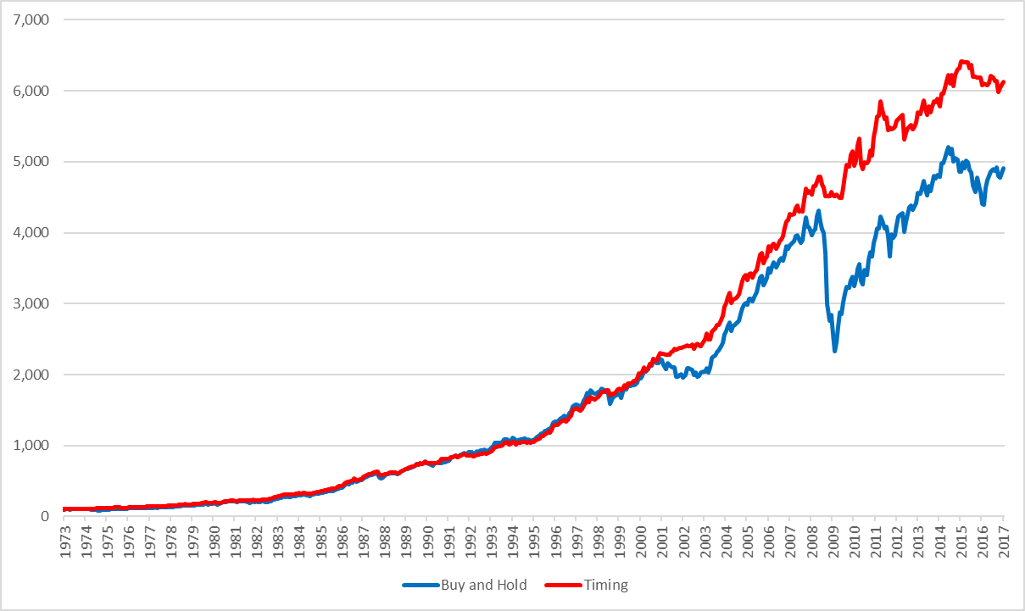

Table 6 - Summary of Returns for Buy and Hold vs Timing Model

|  |  |  |  |  |  |  |
| --- | --- | --- | --- | --- | --- | --- |
|  | 1973-2005 | | 1973-2012 | | 1973-2016 | |
|  | B&H | Timing | B&H | Timing | B&H | Timing |
| CAGR | 11.30% | 11.58% | 9.98% | 10.61% | 9.29% | 9.84% |
| Volatility | 8.98% | 6.93% | 10.27% | 7.01% | 10.09% | 6.87% |
| Skew | -0.45 | -0.48 | -1.09 | -0.54 | -1.02 | -0.48 |
| Kurtosis | 1.48 | 2.57 | 5.23 | 2.41 | 5.06 | 2.35 |
| Inflation CAGR | 4.77% | 4.77% | 4.33% | 4.33% | 4.04% | 4.04% |
| % in the Market | 100.00% | 72.29% | 100.00% | 71.23% | 100.00% | 70.81% |
| % positive Months | 67.76% | 73.55% | 66.94% | 72.14% | 65.60% | 70.51% |
| Best Month | 9.10% | 6.58% | 9.22% | 6.58% | 9.22% | 6.58% |
| Worst Month | -9.23% | -9.29% | -19.34% | -9.29% | -19.34% | -9.29% |
| Max Drawdown | -19.61% | -9.56% | -46.10% | -9.56% | -46.10% | -9.56% |
| Max Drawdown / CAGR | 1.74 | 0.83 | 4.62 | 0.90 | 4.96 | 0.97 |
| Sharpe Ratio (4.93%) | 0.52 | 0.72 | 0.42 | 0.70 | 0.41 | 0.68 |
| Sortino Ratio | 0.62 | 0.88 | 0.44 | 0.77 | 0.42 | 0.73 |
| MAR Ratio | 0.58 | 1.21 | 0.22 | 1.11 | 0.20 | 1.03 |
| Ulcer Index | 4.05 | 1.73 | 8.09 | 2.29 | 7.95 | 2.36 |

Reviewing the performance of the asset allocation strategies since Faber first published his research in 2006, it appears the absolute performance and risk adjusted performance has decreased and may be slightly below any expectations set by the original research paper. The CAGR for both the buy and hold strategy and the timing strategy has decreased by approximately 2% whilst volatility has remained fairly constant, or in the buy and hold strategy’s case increased.

Figure 5 - Buy and Hold vs. Timing Model 2006-2016, Non-log scale

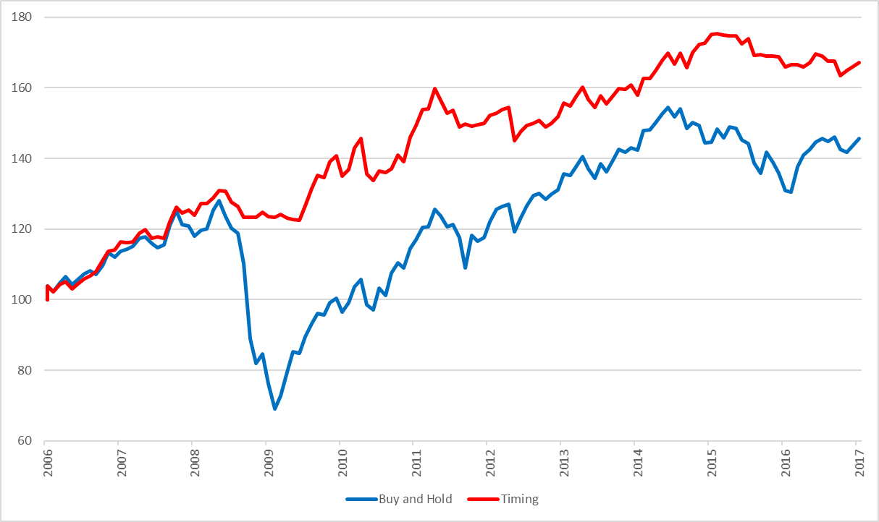

Figure 6 - Buy and Hold vs. Timing Model Drawdowns, 2006-2016

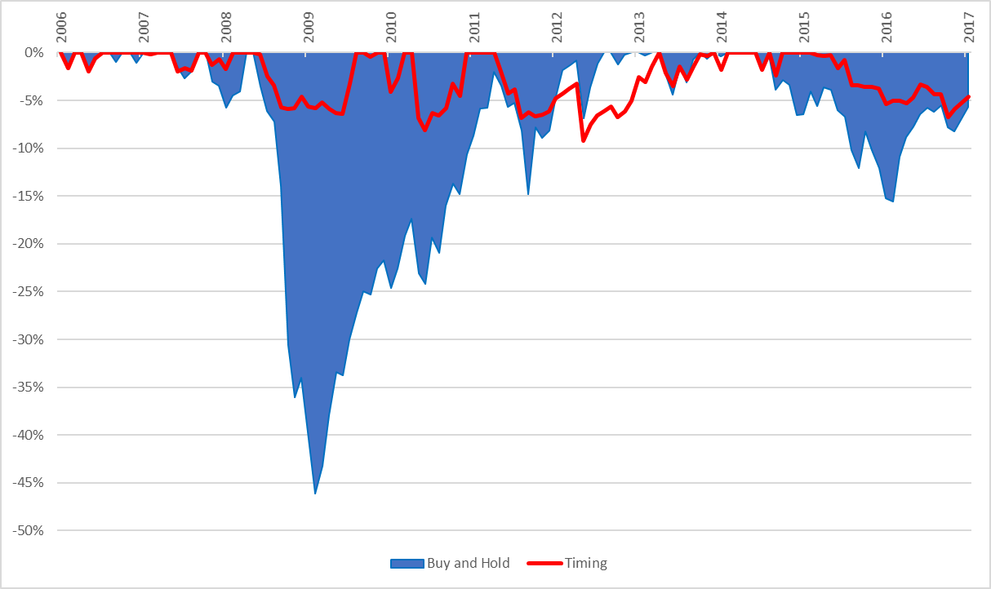

Figure 7 - Rolling 12-month Annualised Returns 2006-2016

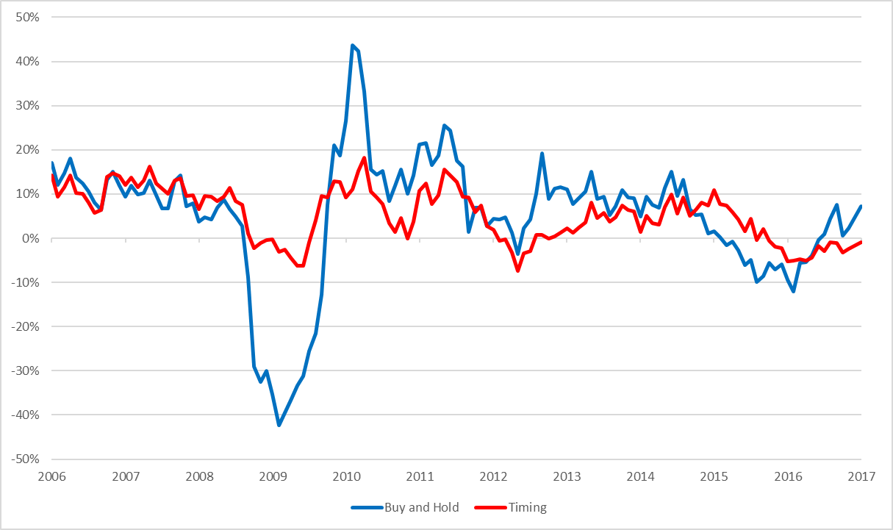

Investors who initiated the timing strategy after the research was first published in 2006/2007 would likely have been pleased with the initial performance. The timing system removed exposure to the market during the financial crisis of 2007-2008 reducing drawdowns to single figures despite the comparison buy and hold portfolio suffering its greatest drawdown since 1972 of 46.1%. Since then, most asset classes have recovered and between 2010-2016, investors in the timing strategy expecting double figure absolute returns have experienced a CAGR of 4.8%. As major benchmarks such as the S&P and Dow Jones Indices make regular news headlines for reaching new all-time highs, it’s easy to imagine investors questioning their choice of strategy over this period.

# Analysis of Performance

## Diversification and Modern Portfolio Theory

One of the core drivers of the absolute returns of the strategies within Faber’s paper is diversification. “Diversification is often spoken of as the only free lunch in investing” (Jennings & Payne, 2016) and has the ability to enhance returns without necessarily increasing risk. The proverb “don’t put all your eggs in one basket” explains it succinctly; invest in a portfolio of different assets and you’ll always have less (or at most equal) risk to the riskiest asset on its own. The benefits of diversification are well known and have been acknowledged for thousands of years. The bible book of Ecclesiastes, thought to have been written around 900BC, tells the reader to “divide your investments among many places, for you do not know what risks might lie ahead” (Ecclesiastes 11:2). Today some successful hedge fund managers see diversification as “the single most important factor to influence the overall long term results” (Clenow A. , 2013).

In 1952 Dr Harry Markowitz published his seminal paper Portfolio Selection (Portfolio Selection, 1952) introducing practitioners to a mathematical framework that explained the benefits of portfolio diversification. Stating rational investors desired returns and disliked variance, he hypothesised the E-V rule used to create efficient portfolios of diversified securities. Although admitting that diversification could not completely eliminate all variance, he showed investors were able to use the E-V rule to derive an optimal portfolio of assets with either the lowest risk for a given level of expected return or the highest expected return for a given level of risk. Markowitz’s paper notes that although the E-V rule identifies diversification as a driver for more efficient portfolios, it requires the right kind of diversification of a selection of securities with low covariance among themselves. Markowitz’s work contributed to what is known today as Modern Portfolio Theory and eventually won him a Nobel prize in 1990.

Modern Portfolio Theory has several criticisms however. The risk, return and correlation inputs into the model are based on expected values assumed to stay constant over time and returns are assumed to follow a Gaussian/normal distribution. Risk in modern portfolio theory is represented by variance, however its questionable whether rational investors will still dislike variance when an asset is moving in their desired direction. Modern portfolio theory manages risk through diversification however it ignores that during extreme market panic, correlations tend towards one.

Global financial market crises in the 1987, 1998, 2001 and 2008 have shown that in these times markets tend to behave as one (Sandoval Jr & Franca, 2010). It’s in these periods that diversification does little to reduce drawdowns and where trend following market timing strategies have demonstrated value protecting the returns of a diversified portfolio.

Trend following is conceptually a very basic strategy – when prices start moving in a direction, jump on the trend and follow it. When prices stop trending and begin to move against you, take your profits or cut your losses. The strategy never buys at the very bottom nor sells at the very top but rather focuses on catching the majority of a long extended price move in the middle.

On the surface trend following appears to be similar to momentum strategies and is even used regularly used by professional asset managers when marketing momentum based strategies. Unlike momentum strategies, applying trend following to a single asset class is unlikely to be successful and have poor performance. Trend following requires a diversified set of markets to perform successfully and the fundamental premise of trend following is based on diversification (Clenow A. F., 2015). Individual asset classes will have extended periods of time where the market is range bound and trend following strategies will be unsuccessful. By trading multiple asset classes, it’s likely at least one asset class is trending and the strategy participates in these moves compensating for losses in the range bound markets elsewhere.

Trend following has had plenty of criticism over the years especially from classical economists supporting efficient markets. However, plenty of empirical evidence combined with strong performance numbers, especially during periods of extreme equity markets drawdowns, has seen the use of trend following rapidly grow as an investment strategy over the last 40 years.

Greyserman & Kaminski (2014) analyse the performance of trend following from 1223 to 2013 using a simple trend following strategy over a unique dataset for 84 markets in equity, fixed income, foreign exchange and commodity markets. They find trends exist in market prices due to fundamental, technical and behaviour reasons but ultimately conclude that trend followers don’t care about the underlying reason and just want to ride the trend whenever the opportunity arrives. They find the driver of performance in a trend following strategy to be the ability to cut losses and take profits rather than the entry signal to get into the trend. Michael Covel (2013) identifies that trend following traders use mechanical trading systems to gain this ability to cut losses and take profits. Mechanical trading systems are based on an objective set of rules and remove discretionary decisions subject to emotion and behavioural biases.

Ultimately trend following timing strategies are risk reduction techniques. They remove exposure to a position during long periods of drawdown without necessarily penalising overall long term returns. A simple mechanical trend following strategy helps to avoid cognitive biases humans exhibit when making trading decisions such as anchoring bias, loss aversion, illusion of control. By managing the downside and overlaying a trend following strategy, returns that are usually negative skewed can be converted into positive skewed distributions. Faber (2007) identifies that most common asset classes experience painful drawdowns with multiple examples of 40-100% drawdowns. Trend following reduces volatility and by being out of markets during these substantial periods of decline, avoids long painful drawdowns for the investor.

Faber’s simple five asset class equal weighted allocation, even on a buy and hold basis, presents evidence of the benefits of diversification. The trend following timing overlay manages risk and results in a reduction of volatility at no expense to returns. Crucially the timing signal reduces portfolio drawdowns to the point that the investor only experiences one down year since 1973, with that being a very palatable -1%. Trend following isn’t about achieving superior absolute returns – it’s about avoiding the painful drawdowns which can destroy multiple previous years of gains. This combined with the power of compounding may result in equal or even better absolute returns over the long run, however more importantly consistently provides improved risk adjusted returns and avoids the risk of ruin.

## Recent Performance and the Financialisation of Commodities

It’s apparent since Faber originally published his first working paper in 2006, performance of the equal weighted five asset class buy and hold portfolio hasn’t been as impressive as historical performance. With the global financial crash in 2007-2008, CAGR between 2006-2016 deteriorated to 3.61% compared to the 11.30% seen between 1973-2006. Volatility also increased from 8.98% to 12.74% and perhaps most painfully felt by investors, the buy and hold portfolio had its largest maximum drawdown ever, experiencing a maximum drawdown of -46.1% or more than double compared to the previous periods maximum drawdown of -19.61%. The Sharpe ratio from 1973-2005 of 0.52 dropped to 0.20 in the following 10 years. Did Faber suffer from hindsight bias when he selected the assets for his equal weighted buy and hold portfolio or can this performance deterioration over the last 10 years be explained elsewhere.

Reviewing the individual returns of each asset class between 2006-2016, it’s clear that commodities were the worst performing asset class. They are largely responsible for dragging the overall performance of the diversified buy and hold portfolio down. Since 2006, commodities have a CAGR of -8.47%, volatility higher than all other asset classes of 23.33%, as well as a max drawdown of 80.9%. This in a period where other assets have continued to show a positive CAGR despite also suffering significant drawdowns in the global crisis of 2008.

Figure 8 - Asset Class Returns 2006-2016

With hindsight if commodities were excluded from the buy and hold portfolio over the last 10 years, absolute returns and risk adjusted metrics would have been considerably better for both the buy and hold strategy and the timing model.

Table 7 – Performance with and without commodities 2006-2016

|  |  |  |  |  |
| --- | --- | --- | --- | --- |
| 2006-2016 | B&H | Timing | B&H ex GSCI | Timing ex GSCI |
| CAGR | 3.61% | 4.84% | 6.36% | 6.35% |
| Volatility | 12.74% | 6.49% | 12.61% | 6.65% |
| Skew | -1.39 | -0.61 | -1.03 | -0.21 |
| Kurtosis | 5.76 | 1.80 | 4.29 | 0.20 |
| Inflation CAGR | 1.86% | 1.86% | 1.86% | 1.86% |
| % in the Market | 100.00% | 66.32% | 100.00% | 71.05% |
| % positive Months | 59.40% | 61.65% | 61.65% | 63.16% |
| Best Month | 9.22% | 5.00% | 11.75% | 5.40% |
| Worst Month | -19.34% | -6.87% | -17.12% | -5.28% |
| Max Drawdown | -46.10% | -9.22% | -43.39% | -6.84% |
| Max Drawdown / CAGR | 12.76 | 1.91 | 6.83 | 1.08 |
| Sharpe Ratio (4.93%) | 0.20 | 0.57 | 0.41 | 0.79 |
| Sortino Ratio | 0.13 | 0.34 | 0.23 | 0.48 |
| MAR Ratio | 0.08 | 0.52 | 0.15 | 0.93 |
| Ulcer Index | 14.23 | 3.65 | 11.75 | 3.00 |

In the 40 year period before 2006, there have multiple other commodity drawdowns and financial crises. Taking the same approach and removing commodities from the portfolio during this time would have resulted in far worse performance for the investor in either the buy and hold or timing strategy. The results show the diversifying value of commodities when combined with the other asset classes.

Table 8 – Performance with and without commodities 1973-2006

|  |  |  |  |  |
| --- | --- | --- | --- | --- |
|  | B&H | Timing | B&H ex GSCI | Timing ex GSCI |
| CAGR | 11.30% | 11.58% | 10.73% | 11.15% |
| Volatility | 8.98% | 6.93% | 10.33% | 7.43% |
| Skew | -0.45 | -0.48 | -0.25 | -0.53 |
| Kurtosis | 1.48 | 2.57 | 2.39 | 3.08 |
| Inflation CAGR | 4.77% | 4.77% | 4.77% | 4.77% |
| % in the Market | 100.00% | 22.22% | 100.00% | 23.80% |
| % positive Months | 67.76% | 73.55% | 68.01% | 75.06% |
| Best Month | 9.10% | 6.58% | 15.28% | 8.10% |
| Worst Month | -9.23% | -9.29% | -11.03% | -8.61% |
| Max Drawdown | -19.61% | -9.56% | -34.09% | -9.23% |
| Max Drawdown / CAGR | 1.74 | 0.83 | 3.18 | 0.83 |
| Sharpe Ratio (4.93%) | 0.52 | 0.72 | 0.41 | 0.62 |
| Sortino Ratio | 0.62 | 0.88 | 0.51 | 0.74 |
| MAR Ratio | 0.58 | 1.21 | 0.31 | 1.21 |
| Ulcer Index | 4.05 | 1.73 | 6.55 | 2.25 |

Comparing the two periods it appears that something significant has happened in the most recent period that has resulted in the decline of the diversifying value of commodities to the other asset classes. Reviewing correlations between commodities and SP500, EAFE and NAREIT shows that correlations in 2008 all increased to some of the highest levels they have been historically since 1972 and that they remained at these elevated levels for a much longer period than in the past.

Figure 9 – 36 month Rolling Correlations with GSCI, 1973-2016

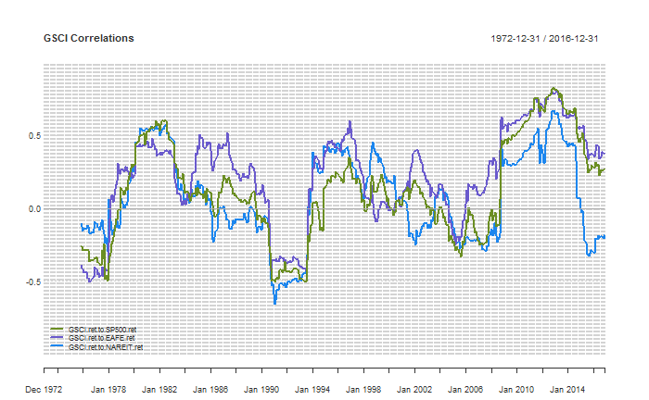

A popular topic in research around the time of the release of Faber’s first white paper was the strong diversifying performance of commodities. Two years before Faber released his working version, (Gorton & Rouwenhorst, 2004) released a working paper titled Facts and Fantasies About Commodity Futures highlighting commodities as an ideal diversifier for equity and bond portfolios. They showed that an equal weighted index of commodity futures between 1959 and 2004 produced equity-like returns, slightly lower risk than stocks as measured by standard deviation and less downside risk due to positively skewed returns with relatively high kurtosis. With a negative correlation with both stocks and bonds over most horizons, they concluded commodities as being an especially effective in providing diversification over both stock and bond portfolios.

Following this, in 2006 Ibbotson Associates released a report for PIMCO titled Strategic Asset Allocation and Commodities (Ibbotson Associates, 2006) that analysed the role of commodities within a strategic asset allocation setting. Comparing the returns from 1970 to 2005 of a composite commodity index against US and International stocks, US and International Bonds, Treasury Bills and Inflation, they found that commodities were the top performing asset. During periods of high inflation commodities had the highest arithmetic and compounded returns by a wide margin and in periods of low margin they still returned double digit returns. Ibbotson Associates also identified that commodities had the lowest average correlation to the other asset classes, concluding that including commodities in an asset allocation improved the risk return characteristics of the efficient frontier.

These papers combined with other literature (Erb & Harvey, 2006) drove increased long only investment into commodities financial instruments by investment managers looking to improve risk adjusted portfolio performance. It was reported that there was a significant increase in inflows with hundreds of billions of U.S. dollars flowing into long only commodity investments between 2003-2008 (Bhardwaj, Gorton, & Rouwenhorst, 2015; Irwin & Sanders, 2010). This is thought to have resulted in structural changes in the commodities market later termed financialisation by Domanski and Heath (Financial Investors and Commodity Markets, 2007).

As a result of financialisation, it was thought commodities were no longer driven purely by commodity fundamentals and rather by macroeconomic views of investment managers. Expectations were for increased correlations among commodities and other asset classes. Zaremba (2015) provides one of the more intuitive explanations for this expectation. With an increased number of financial investors holding on to a similar asset allocation of stocks, bonds and commodities, any external shock causing severe capital outflows will necessitate selling of all asset classes in the portfolio at the same time to free up capital, causing correlation to rise. A resulting theme in recent research (Bhardwaj, Gorton, & Rouwenhorst, 2015; Silvennoinen & Thorp, 2009; Cheung & Miu, 2010) reviews financialisation and the recent performance of the commodities sector since financialisation and debate the idea that commodities should no longer be included in a diversified investment portfolio. They conclude that commodities may no longer provide diversifying protection in future times of financial distress similar to the financial crisis of 2008.

Today there are arguments for both including and excluding commodities in an asset allocation. On one hand commodity correlations have returned towards pre-2008 financial crisis levels. There is a wealth of recent research (Bhardwaj, Gorton, & Rouwenhorst, 2015; Levine, Ooi, & Richardson, 2016) showing commodities to have strong returns during periods of growth and high inflation as well as low correlation with stocks and bonds over long horizons, concluding that despite the most recent years of performance and high correlation, commodity futures are still likely to add diversification protection to a portfolio of assets under these regimes in the future.

On the other hand, many (Lombardi & Ravazzolo, 2013; Zaremba, 2015) have argued that the diversification benefits of commodity may not be valid anymore. Due to the structural changes from financialisation resulting in increased correlations during macro market shocks, it has been argued that commodities no longer offer diversification protection for a portfolio with stocks and bonds during financial crisis. Antonacci (2017) also argues that due to the nature of commodity markets changing from financialisation, the papers using data before this period succumb to aggregation bias and will have less forecasting power for the period post financialisation.

Without being able to predict the future and prove which argument is correct, it’s perhaps now a good time to review the performance of the timing model between 2006-2016. Like the buy and hold portfolio, returns were less than expected (4.84% vs 11.58%) however lower volatility resulted in less deterioration of risk adjusted measures such as the Sharpe ratio. Importantly for investors, the max drawdown stayed in line with expectations and was only -9.22% in a period with another financial crisis resulting in the buy and hold experiencing a -46.10% drawdown. Its apparent that the trend following timing strategy can mitigate some of the negative impact of financialisation during crises, removing the investor from commodities during sharp drawdowns. Potentially entering an expected period of rising inflation and growth supports including commodities in the diversified asset allocation. The timing strategy allows the investor to participate in any potential upside under these regimes, whilst likely protecting the investor somewhat in a future financial crisis from deep drawdowns, where it’s not unreasonable to expect correlations to again increase towards one for all asset classes.

## Performance under rising interest rates

It’s well acknowledged that the world has just experienced one of the longest bull markets for fixed income. US Government 10 Year Bond Yields have steadily fallen from highs of 15.84% in 1981 to recent lows of 1.64%. This has resulted in a 35+ year bull market for bond returns.

Figure 10 - US 10 Year Constant Maturity Yields

Figure 11 - US10YR Total Returns, Log Scale

Recently inflammatory news headlines have been common questioning whether trend following strategies can deliver the same performance in a rising rates cycle. Some critics have questioned whether trend following strategies only generate positive risk adjusted returns during periods of falling rates. To analyse potential performance under a rising rates regime, let’s review the period 1973-1981 where it was a clear rising rates environment.

Figure 12 - Asset Class Returns 1973-1981, Non log scale

Table 9 - Asset Class Returns 1973-1981

|  |  |  |  |  |  |  |
| --- | --- | --- | --- | --- | --- | --- |
|  | TBILLS | SP500 | EAFE | US10YR | GSCI | NAREIT |
| Return | 8.41% | 5.19% | 7.97% | 3.65% | 12.81% | 6.85% |
| Volatility | 0.89% | 16.56% | 16.96% | 9.27% | 23.53% | 22.15% |
| Sharpe (8.41%) | 0.00 | -0.18 | -0.03 | -0.48 | 0.17 | -0.07 |
| MaxDD | 0.00% | -42.65% | -41.53% | -15.75% | -37.45% | -58.10% |
| Inflation CAGR | 9.23% | 9.23% | 9.23% | 9.23% | 9.23% | 9.23% |

Reviewing the asset class performance over this period its immediately apparent that commodities were the strongest performing asset class. This supports research (Bhardwaj, Gorton, & Rouwenhorst, 2015; Levine, Ooi, & Richardson, 2016) identifying rising inflation as a regime where commodities deliver strong performance. Commodities were the only asset class to beat inflation with all other asset classes underperforming both inflation and risk free returns.

During this rising interest rate period, the buy and hold equal asset allocation and timing model both deliver absolute returns slightly better than risk free rates however with much higher volatility. Reviewing the risk adjusted metrics, the timing model outperforms the buy and hold strategy demonstrating value in using a trend following strategy in a rising rates environment. The absolute returns may not be as attractive as other regimes, however the ability of the timing model to avoid drawdowns is responsible for helping to deliver the strong long term compounded returns seen over longer periods. Faber & Richardson (2009) identify that the value of a trend following timing model to add value needs to be recognised over the course of an entire business cycle.

Figure 13 - Performance under rising rates 1973-1981

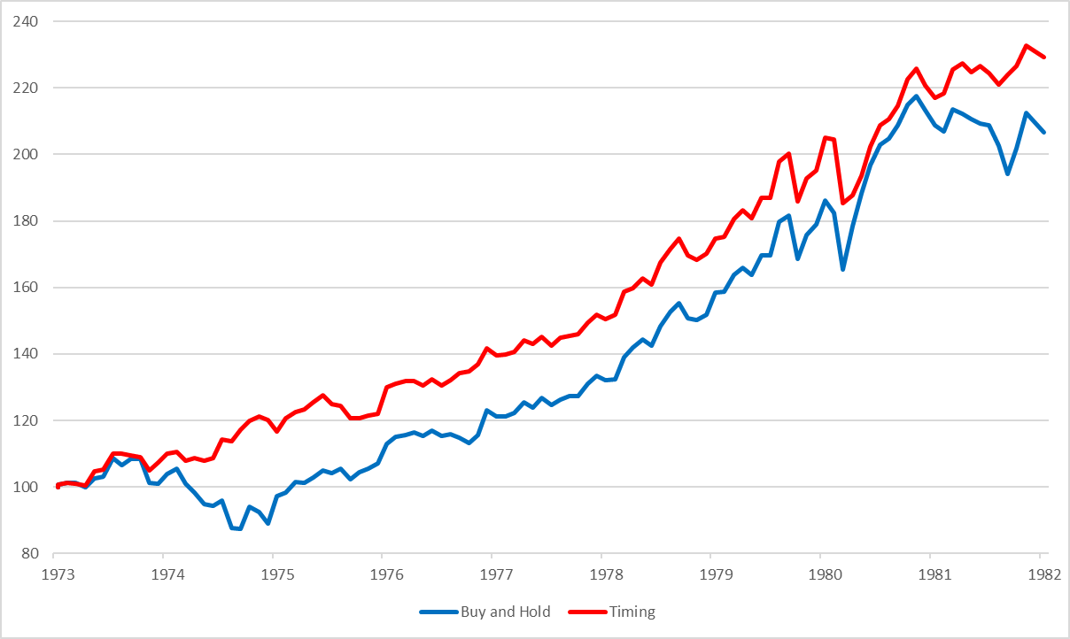

Figure 14 - Drawdowns under rising rates 1973-1981

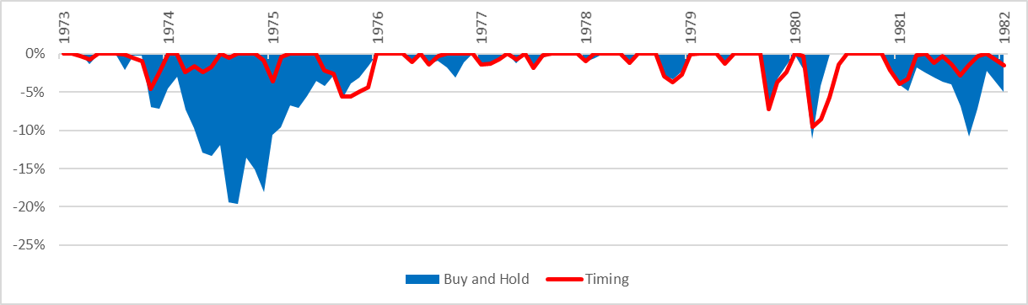

Table 10 – Performance under rising rates 1973-1981

|  |  |  |
| --- | --- | --- |
|  | Buy and Hold | Timing |
| CAGR | 8.61% | 9.86% |
| Volatility | 10.79% | 8.14% |
| Skew | -0.33 | -0.80 |
| Kurtosis | 1.20 | 3.08 |
| Inflation CAGR | 9.23% | 9.23% |
| % in the Market | 100.00% | 68.07% |
| % positive Months | 60.55% | 69.72% |
| Best Month | 9.10% | 6.57% |
| Worst Month | -9.23% | -9.29% |
| Max Drawdown | -19.61% | -9.56% |
| Max Drawdown / CAGR | 2.28 | 0.97 |
| Sharpe Ratio (8.37%) | 0.00 | 0.14 |
| Sortino Ratio | 0.39 | 0.58 |
| MAR Ratio | 0.44 | 1.03 |
| Ulcer Index | 5.49 | 2.20 |

# Behavioural implications for Trend Following Investors

Despite delivering attractive returns, there are several behavioural implications that make it difficult for investors to trade quantitative trend following strategies. Humans are subject to numerous behavioural biases and there are currently over 175 biases listed on Wikipedia grouped into various categories. These behavioural biases are known to interfere with the investment process, lead to sub optimal decisions and “almost guarantee losses in the markets” (Covel, 2013). One such example is loss aversion, where investors dislike losses so much that they tend to hold onto losing trades and let losses grow much larger than they had planned rather than accepting they were wrong and exiting the trade at a small loss.

A quantitative trend following approach can help investors avoid these behavioural biases humans make in their investment decision process (Faber & Richardson, 2009). These strategies remove discretion from the investment decisions and force positions to be cut when they make a small loss. However even a quantitative trend following strategies can be difficult for an investor to stick to.

Trend following strategies generally have a low win ratio and a high percentage of losing trades. Most systems have a win ratio between 30-40% and can suffer multiple losing trades in a row. This can be difficult for the investor to tolerate and if they do not have the discipline to consistently enter every trade, they might miss the occasional huge winning trade that delivers the majority of the overall returns. The rules based process of cutting short losses and letting winners run is also the reverse of investors’ natural instincts (Clare, Seaton, Smith, & Thomas, 2012).

Another implication of the quantitative approach is that it can be boring to trade. Black and Scholes (1973) report empirical evidence where investors rarely follow a rational approach. These investors, nicknamed gamblers, either enjoy the action of investing and derive a measure of utility from talking to their brokers, gathering information and trading buys and sells. Others, nicknamed the fools, wrongly believe they can make money by trading on information because they have been lucky in the past. Both investors are better off following a specific approach but empirical evidence shows that they rarely are able to follow the approach.

Another issue with trend following strategies is that they can be incredibly simple. Investors suffer from narrative fallacy and have a limited ability to look at sequences of facts without weaving an explanation into them. Systematic trend following strategies generate buy and sell signals using price based indicators. There is often no understood fundamental reason for the signal and investors can find it difficult to trade with such uncertainty.

Lastly trend following strategies are known to have periods of underperformance. Despite delivering superior overall risk adjusted returns over a long time horizon, trend following strategies can at times underperform buy and hold strategies for long periods, especially during bull markets. Gray (2016), researching the performance of optimal market timing strategies with hindsight, concludes that market timing strategies chosen with perfect foresight may have optimal returns but still show investor significant pain and drawdowns along the way. He concludes that investors must have a long horizon to stick to a market timing strategy and suggests few investors actually have that. Compounding the difficulty, investors suffer anxiety from tracking error, both to benchmarks and other investors. In strong bull markets where equity markets are making headlines for settling new all time highs, the investor is likely to question their choice of strategy. When the investor chats to another investor participating in the equity bull market and outperforming, the anxiety is going to get worse and make it harder to stick to the strategy.

The quantitative trend following approach is designed to help the investor avoid behavioural biases taking control and affecting their investment decisions. Even if the approach is optimal, it’s of no use unless an investor can stick to it. For a quantitative approach to tactical asset allocation to be successful, the investor needs to acknowledge three areas:

1. The investor has to be comfortable with the concept of diversification as the driver of long term returns

Diversification benefits are well acknowledged in academia however with the benefit of perfect hindsight, the performance results of one specific diversified portfolio is unlikely to be ever be optimal. There will always be an asset class that underperforms and drags down the returns and if excluded in hindsight would have resulted in better portfolio returns. The value of diversification comes from its ability to handle uncertainty. Investors don’t have perfect foresight and aren’t able to predict what asset classes to include or exclude so diversification is used to manage uncertainty. For diversification to work, it requires the investor to hold a long-term horizon. If the holding period is too short, the investor will not fully achieve the benefits of complementarity.

1. The investor has to be comfortable with the quantitative trend following approach

The trend following strategy is designed to manage risk and prevent losses. We don’t know if or what asset class will underperform but when one does, the investor must let the trend following strategy minimise its impact on portfolio returns. Quantitative trend following strategies mitigate the potentially damaging behavioural biases that often lead to poor investment decisions such as holding onto losing trades. A simple rule based trend following approach can manage behavioural biases and force investors to exit losses before they cause significant damage. Despite the simplicity of the strategy, there is a wealth of research (Greyserman & Kaminski, 2014) that shows the strategy to deliver strong risk adjusted performance over hundreds of years. Some research (Clare, Seaton, Smith, & Thomas, 2012) even credits trend following success historically by taking advantage of behavioural bias impacts in the market.

1. Investors need to be aware of their emotions trading a quantitative trend following strategy

Despite using a trend following strategy to manage biases, investors are likely to still have biases influence their decisions trading the strategy. There are going to be periods of underperformance vs other alternatives. The strategy is not going to be exciting to trade and there is no entertaining narrative to explain why the 10-month timing signal is the right time to enter or exit a trade. There will be multiple periods of consecutive losing trades which will create doubt. For the strategy to work the system must be followed with discipline. Ultimately the approach is simple to follow but the investors emotions may say otherwise.

Ultimately an investor has to be comfortable with the strategy, take a long term view and understand their emotions and how behavioural biases are going to test their discipline to stick to the rules of the strategy.

# Improving returns

Over a long time horizon, the market timing trend following quantitative approach provides superior risk adjusted returns compared to a buy and hold alternative. However no market timing strategy is profitable in all market conditions and Faber & Richardson (2009) identify that trend following timing strategies can underperform the buy and hold strategy around 40% of the time.

Figure 16 - Timing Tracking Error to B&H 12-month Rolling Annualised Returns

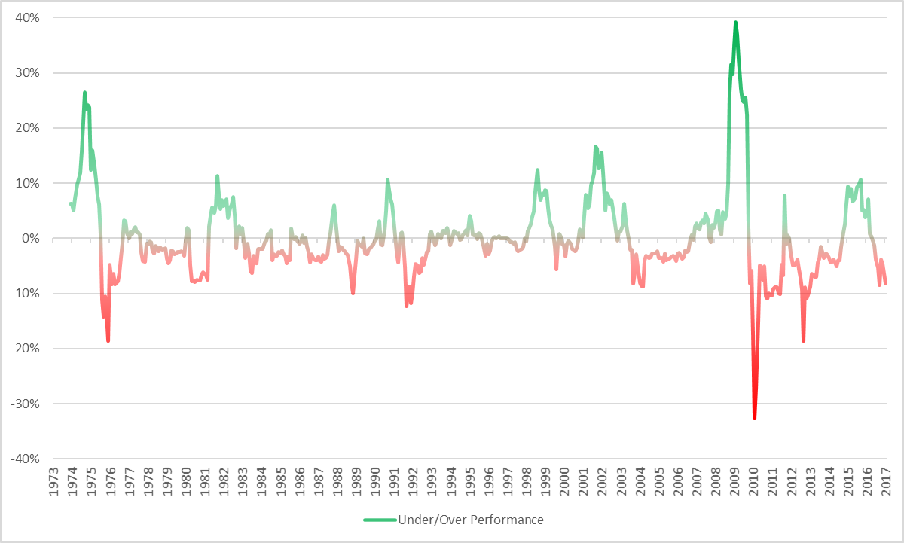

In this section I explore three areas to limit temporary underperformance, smooth out the return profile and achieve equal or improved risk adjusted performance which overall may prove beneficial to the core timing model:

* Further asset allocation diversification
* Alternative trend following market timing strategies
* Diversification of trading strategies and parameters

## Asset Allocation Diversification

When investors hear the term diversification they generally think of the diversification of the underlying assets within their portfolio. Faber (2013) comments that his five-asset class equal weighted asset allocation was chosen purely for simplicity. In the 2013 update he tests expanding the portfolio to a thirteen-asset portfolio of different allocations. As expected the additional assets improve the risk adjusted performance of both the buy and hold and timing strategy. Another option is to split asset classes into sub components. Clare et al (2012) find splitting an asset class into its component parts adds value in a trend following strategy. Historically exposure to many asset classes were only available to institutions. However today there are hundreds of asset class investment products accessible to all investors such as ETFs and mutual funds. It makes sense then to look at adding further asset classes that are low correlated to the existing strategy.

One such asset class worth investigating is Bitcoin, a cryptocurrency introduced in 2008. Bitcoin falls within the third superclass of assets known as store of value assets which generally serve as a refuge during uncertainty (Greer, 1997). Despite only having a short period of pricing history from late 2010, Bitcoin has so far demonstrated extremely low correlation to all other asset classes.

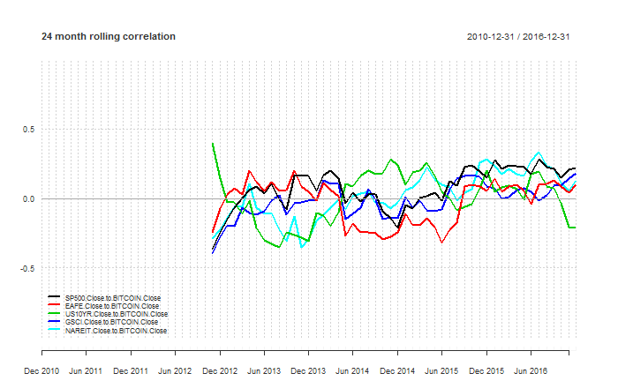

Bitcoin trades on multiple unregulated exchanges, has high volatility and only a relatively short history. Due to liquidity constraints, many large investment managers have little if any exposure making the asset class far less likely to suffer the effects of financialisation in market crises. For retail investors it appears an attractive asset to add into the asset allocation. Ultimately the length of pricing history is short and the asset has yet to experience a market crisis. Without falling subject to the law of small numbers and gambler’s fallacy (Tversky & Kahneman, 1971), its unwise to make predictions of the diversifying value of adding Bitcoin to the asset allocation just yet. However for investors who can handle its volatility it’s definitely one asset class worth keeping an eye on in the future to improve returns.

There are hundreds of possible combinations of asset classes and weightings that can be practically traded by all investors. Cilella (2015) tested the effects of diversification at asset level on performance by using a Monte Carlo approach to create 1000 different portfolios of 15, 25 and 40 instruments before then comparing strategy performance over 20 years. His results found two main observations. Firstly portfolios with a greater number of instruments generally resulted in better risk adjusted performance with higher CAGR and lower maximum drawdowns. Secondly he found that with a more diversified portfolio, there was less deviation in the results of the random portfolios. Although performance of portfolios of the same number of instruments was spread across a wide range, portfolios with greater diversification showed lower variability and more consistent results. Disregarding costs and other constraints, there is extensive research identifying the value of greater levels of portfolio level diversification. Apart from better risk adjusted performance, greater levels of diversification will result in less variability in the strategy and less periods of significant underperformance.

## Alternative Trend Following Strategies - Avoiding Whipsaws

The underlying system in Faber’s timing model is a trend following system based on a simple moving average. Trend following strategies are designed to identify trends and react by entering trades that will stay with the trend for as long as it lasts. The trading philosophy doesn’t attempt to predict the bottom or top of a market but rather react to a price move and capture as much of the remainder while it lasts. A drawback with trend following strategies is that performance generally suffers in consolidating, non-trending or range bound markets. These sideways moving markets generate several false entry signals as the price whipsaws and quickly moves through the moving average in both directions, resulting in multiple buy and sell signals and trades for a small loss each time. Ultimately these periods are responsible for the low overall 30-40% win rate of trend following strategies. It’s at these times investors are likely to succumb to pressure from behavioural biases to cut the strategy.

On average the size of the winners when the market is trending is much greater than the several small losses, resulting in the positive expectancy for trend following strategies. However to reduce whipsaws and smooth out the return profile, there are a couple of alternate strategies that can be employed and applied to asset allocation:

* Delayed entry
* Trading envelopes

Ultimately both of these strategies delay entry into a trade and require greater certainty that a trend is present. As a result, they are generally in the market less and can miss short term whipsaws but at the expense of missing out of the first part of a trend. However, the avoidance of costly whipsaw periods in prolonged sideways moving markets can justify their use in choppy markets.

### Delayed entry

This method delays long entry for a set period after a long signal to confirm that the price is still above the moving average and has not fallen back below. It eliminates whipsaws at the expense of missing out of the first part of the move. The delay only applies to the entry of a long position, and if the price falls below the moving average, the position is closed out instantaneously.

In this paper we delay entry for a month. To enter a long position, the price has to cross above the moving average and stay there the next month. Looking at results over the SP500 for the entire period, the performance of the strategy does not look significantly different to the timing strategy. Absolute and risk adjusted return metrics are all in line, perhaps the only distinguishable difference is that the strategy is in the market only 69.19% of the time vs the 74.67% of the timing strategy.

Table 11 - Delayed Entry Strategy Performance 1973-2016

|  |  |  |  |
| --- | --- | --- | --- |
|  | B&H | Timing | Timing Delayed |
| CAGR | 10.19% | 10.35% | 10.03% |
| Volatility | 15.28% | 11.61% | 11.22% |
| Skew | -0.43 | -0.68 | -0.71 |
| Kurtosis | 1.97 | 5.19 | 6.13 |
| Inflation CAGR | 4.04% | 4.04% | 4.04% |
| % in the Market | 100.00% | 74.67% | 69.19% |
| % positive Months | 61.63% | 73.35% | 75.24% |
| Best Month | 16.81% | 13.47% | 13.47% |
| Worst Month | -21.54% | -21.54% | -21.54% |
| Max Drawdown | -50.95% | -23.29% | -23.26% |
| Max Drawdown / CAGR | 5.00 | 2.25 | 2.32 |
| Sharpe Ratio (4.93%) | 0.33 | 0.44 | 0.43 |
| Sortino Ratio | 0.32 | 0.42 | 0.42 |
| MAR Ratio | 0.20 | 0.44 | 0.43 |
| Ulcer Index | 14.45 | 6.19 | 5.93 |

Focusing on a specific period that the SP500 was subject to whipsaws in 1977-1978, the delayed timing strategy’s performance is comparatively much better. The strategy is much more hesitant to enter a long position when the price moves above the moving average. It is only in the market 32% of the time compared to 48% of the time for the Timing strategy. Absolute performance is positive as it ignores two opportunities to enter the market where the traditional timing model entered a long position and immediately got whipsawed out of the trade.

Figure 17 - SP500 Price vs 10m Simple Moving Average 1977-1978

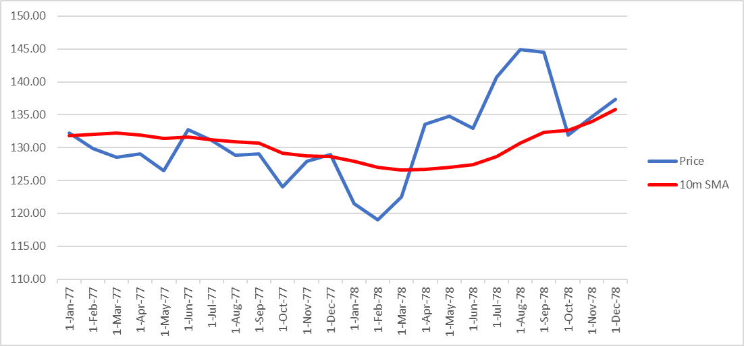

Figure 18 - SP500 Delayed Timing Performance During Whipsaws 1977-1978

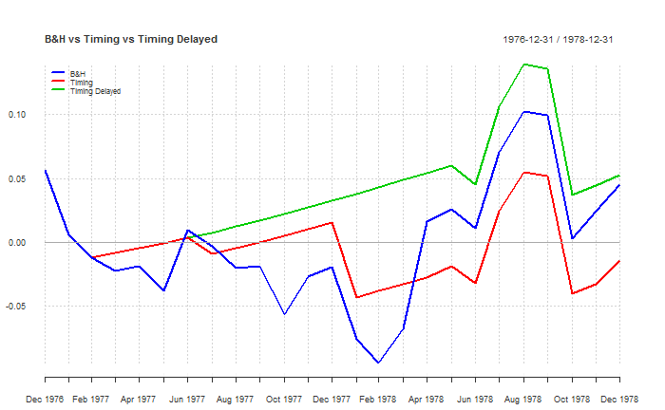

Table 12 - Delayed Timing Performance 1977-1978

|  |  |  |  |
| --- | --- | --- | --- |
|  | B&H | Timing | Timing Delayed |
| CAGR | 2.13% | -0.67% | 2.48% |
| Volatility | 13.66% | 10.51% | 9.52% |
| Skew | 0.00 | -0.84 | -1.03 |
| Kurtosis | 0.09 | 1.93 | 3.81 |
| Inflation CAGR | 7.77% | 7.77% | 7.77% |
| % in the Market | 100.00% | 48.00% | 32.00% |
| % positive Months | 52.00% | 72.00% | 80.00% |
| Best Month | 9.02% | 5.84% | 5.84% |
| Worst Month | -8.72% | -8.72% | -8.72% |
| Max Drawdown | -14.26% | -9.39% | -9.01% |
| Max Drawdown / CAGR | 6.69 | -14.06 | 3.63 |
| Sharpe Ratio (4.93%) | -0.29 | -0.62 | -0.38 |
| Sortino Ratio | 0.10 | 0.00 | 0.12 |
| MAR Ratio | 0.15 | -0.07 | 0.28 |
| Ulcer Index | 7.29 | 6.23 | 4.37 |

### Timing Envelopes

Another modification to the timing strategy is to create an envelope around the moving average and require the price to break out higher than normal to enter a long trade. There are multiple variations of this strategy used by investors such as the Keltner Channel Trading strategy. Similar to the delayed timing strategy, this strategy requires the price to demonstrate a stronger trend than just simply crossing above the moving average. Instead the price has to close a specific range above the simple moving average, in this paper’s example 102.5% of the moving average. Commonly the range is based on the ATR indicator. For simplicity in this research 102.5% was chosen though parameter stability was evident across a wide variety of envelope widths. In this example the entry signal is generated when the price crosses above 102.50% of the moving average and exits immediately when the price falls below the moving average. Again the strategy aims to reduce whipsaws at the expense of missing out the first part of any trend. Looking at the SP500 for the entire period, the value of the strategy is slightly better than the original timing strategy with slightly higher CAGR and slightly lower volatility, resulting in improved risk adjusted return metrics. Again, the strategy is in the market for a less time – 70.89% of the time vs the 74.67% of the original timing strategy.

Table 13 - Timing Envelope Strategy Performance 1973-2016

|  |  |  |  |
| --- | --- | --- | --- |
|  | B&H | Timing | Timing Envelope |
| CAGR | 10.19% | 10.35% | 10.96% |
| Volatility | 15.28% | 11.61% | 11.14% |
| Skew | -0.43 | -0.68 | -0.66 |
| Kurtosis | 1.97 | 5.19 | 6.13 |
| Inflation CAGR | 4.04% | 4.04% | 4.04% |
| % in the Market | 100.00% | 74.67% | 70.89% |
| % positive Months | 61.63% | 73.35% | 75.24% |
| Best Month | 16.81% | 13.47% | 13.47% |
| Worst Month | -21.54% | -21.54% | -21.54% |
| Max Drawdown | -50.95% | -23.29% | -23.29% |
| Max Drawdown / CAGR | 5.00 | 2.25 | 2.13 |
| Sharpe Ratio (4.93%) | 0.33 | 0.44 | 0.52 |
| Sortino Ratio | 0.32 | 0.42 | 0.47 |
| MAR Ratio | 0.20 | 0.44 | 0.47 |
| Ulcer Index | 14.45 | 6.19 | 5.36 |

Focusing on a specific period that the SP500 was subject to whipsaws in 1977-1978, the timing envelope makes it harder to enter a long position as the price closing just above the moving average is not strong enough to signal entry. It is in the market 36% of the time compared to 48% of the time for the original timing strategy. Absolute performance is positive as it ignores two opportunities to enter the market that the traditional timing model took and immediately got whipsawed out of the trade.

Figure 19 - Trading Envelope Price Chart 1977-1978

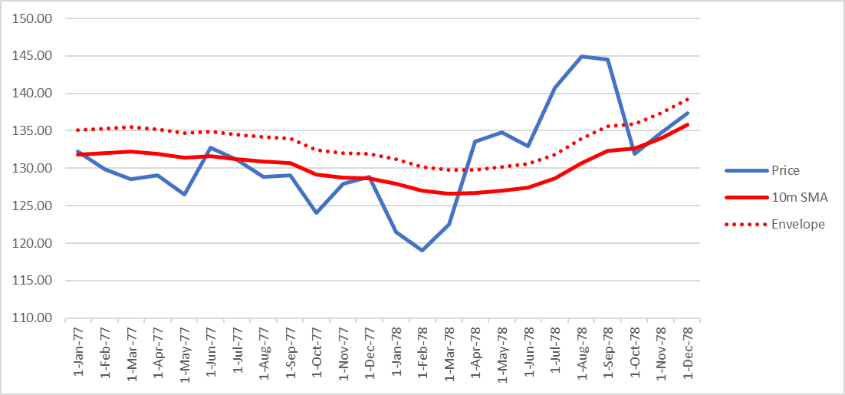

Figure 20 - Trading Envelope Performance During Whipsaws 1977-1978

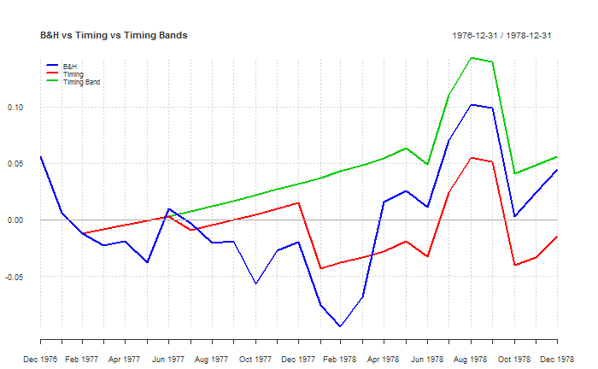

Table 14 - Timing Envelope Strategy Performance 1977-1978

|  |  |  |  |
| --- | --- | --- | --- |
|  | B&H | Timing | Timing Envelope |
| CAGR | 2.13% | -0.67% | 2.67% |
| Volatility | 13.66% | 10.51% | 9.53% |
| Skew | 0.00 | -0.84 | -1.05 |
| Kurtosis | 0.09 | 1.93 | 3.80 |
| Inflation CAGR | 7.77% | 7.77% | 7.77% |
| % in the Market | 100.00% | 48.00% | 36.00% |
| % positive Months | 52.00% | 72.00% | 80.00% |
| Best Month | 9.02% | 5.84% | 5.84% |
| Worst Month | -8.72% | -8.72% | -8.72% |
| Max Drawdown | -14.26% | -9.39% | -9.01% |
| Max Drawdown / CAGR | 6.69 | -14.06 | 3.37 |
| Sharpe Ratio (4.93%) | -0.29 | -0.62 | -0.36 |
| Sortino Ratio | 0.10 | 0.00 | 0.13 |
| MAR Ratio | 0.15 | -0.07 | 0.30 |
| Ulcer Index | 7.29 | 6.23 | 4.37 |

## Diversification of trading strategies and parameters

After exploring diversification of the underlying assets included within the portfolio, the next logical step is to explore diversification at a strategy level. For a buy and hold investment strategy, diversification is limited to the choice of assets included in the portfolio. In an active approach to investing, diversification can be applied to all variables within a trading strategy as well as by combining low correlated trading strategies themselves.

Peter Garnry (2016) demonstrates that combining weak individual trading strategies, which individually offer low risk adjusted returns, into a portfolio results in superior performance with much stronger risk adjusted returns. Over 500 trials he simulates blending 20 individual strategies each with individual Sharpe Ratios of 0.6 into portfolios that run for 10 years. Although absolute returns are not necessarily enhanced, he finds that portfolios of low correlated strategies return significantly improved risk adjusted performance with portfolio Sharpe Ratios of 3, a 370% improvement. The portfolio’s risk adjusted returns quickly decline as correlation increases, however the research shows the benefits of diversification can also be achieved by combining low correlated timing strategies.

One of the simplest and most common ways to diversify Faber’s timing model would be by diversifying the moving average period used in the timing signal and effectively trade multiple time frames. Once created, these different time frame strategies can be combined into a superior portfolio. Faber (2013) acknowledges that stability of using various parameters for the moving average period. Faber uses the 10-month moving average and compares the returns to 3, 6, 9 and 12 month moving averages to find report similar risk adjusted returns. Another two popular time frames used in the trend following community are the 50 day and 100 day moving averages. Converted to monthly 2m and 5m time periods we see similar robustness in the strategy’s performance.

Table 15 - Multiple Time Frame Performance 1973-2016

|  |  |  |  |  |  |
| --- | --- | --- | --- | --- | --- |
|  | B&H | 2M Timing | 5M Timing | 10M Timing | Multi Timing |
| CAGR | 9.29% | 9.49% | 9.27% | 9.84% | 9.57% |
| Volatility | 10.09% | 6.29% | 6.62% | 6.87% | 6.14% |
| Skew | -1.02 | -0.07 | -0.51 | -0.48 | -0.25 |
| Kurtosis | 5.06 | 2.55 | 2.61 | 2.35 | 1.30 |
| Inflation CAGR | 4.04% | 4.04% | 4.04% | 4.04% | 4.04% |
| % in the Market | 100.00% | 59.89% | 65.48% | 70.81% | 0.00% |
| % Positive Months | 65.60% | 71.27% | 70.13% | 70.51% | 70.13% |
| Best Month | 9.22% | 9.22% | 6.57% | 6.58% | 6.18% |
| Worst Month | -19.34% | -7.96% | -9.29% | -9.29% | -6.11% |
| Max Drawdown | -46.10% | -13.29% | -10.71% | -9.56% | -8.65% |
| Max Drawdown / CAGR | 4.96 | 1.40 | 1.16 | 0.97 | 0.90 |
| Sharpe Ratio (4.93%) | 0.41 | 0.69 | 0.62 | 0.68 | 0.72 |
| Sortino Ratio | 0.42 | 0.83 | 0.71 | 0.73 | 0.84 |
| MAR Ratio | 0.20 | 0.71 | 0.87 | 1.03 | 1.11 |
| Ulcer Index | 7.95 | 2.39 | 2.66 | 2.36 | 2.11 |

Similar to Faber’s findings, each timing signal returns individual performance with similar absolute returns, volatility and risk adjusted measures such as Sharpe Ratio. Similar to multiple time frame analysis by Clenow (2013), the longer term strategies applied to multiple assets generally return stronger total returns however at the expense of having slightly higher volatility and more negative skew returns.

Combining the three different time frames into an equal weighted portfolio, we see a slight improvement from the diversification effect as expected from Garnry’s research. The portfolio of multiple time frame strategies shows similar absolute returns of 9.57%. However volatility and maximum drawdown are the lowest of all time frames and as a result, risk adjusted measures such as Sharpe ratio, Sortino ratio, Calmar ratio and Ulcer index are all improved.

The idea of strategy diversification can be extended to include the other strategy ideas in this paper. A multi strategy portfolio consisting of equal weight exposure to the following strategies:

* 2m, 5m, 10m timing strategies
* 2m, 5m, 10m delayed timing strategies
* 2m, 5m, 10m trading envelope strategies

Figure 21 - Buy and Hold vs Timing vs Multi Strat Performance 1973-2016

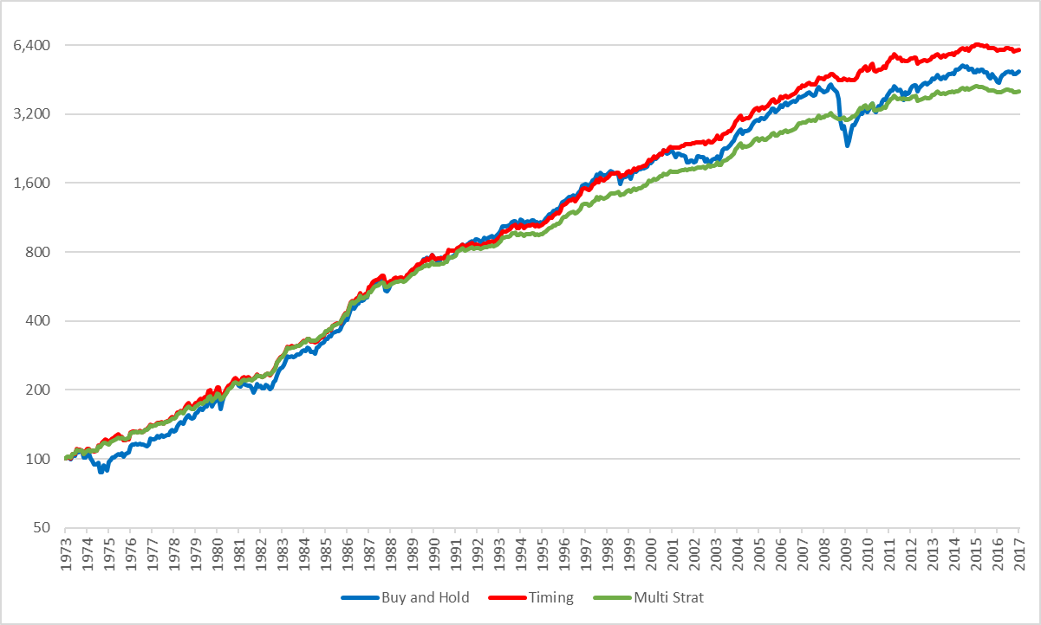

Figure 22 - Buy & Hold vs Timing vs Multi Strategy Drawdowns 1973-2016

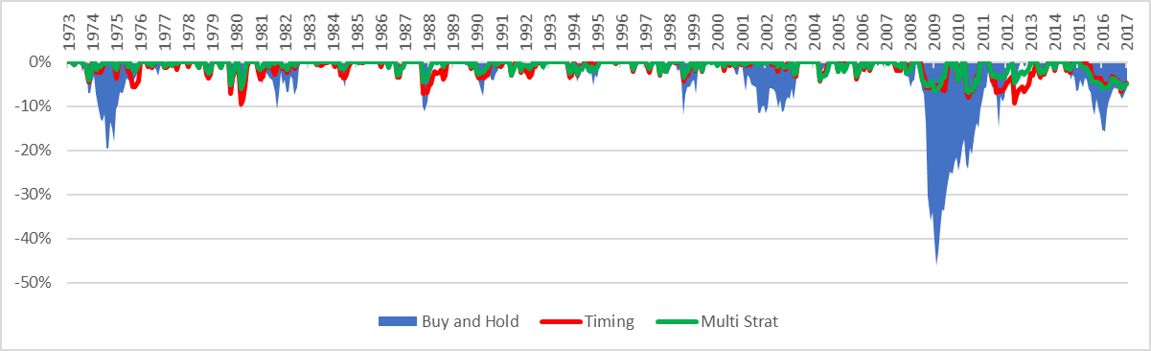

Table 16 - Multi Strategy Performance 1973-2016

|  |  |  |  |
| --- | --- | --- | --- |
|  | B&H | Timing | Multi Strat |
| CAGR | 9.29% | 9.84% | 8.80% |
| Volatility | 10.09% | 6.87% | 5.49% |
| Skew | -1.02 | -0.48 | -0.33 |
| Kurtosis | 5.06 | 2.35 | 2.22 |
| Inflation CAGR | 4.04% | 4.04% | 4.04% |
| % in the Market | 100.00% | 70.81% | 55.04% |
| % positive Months | 65.60% | 70.51% | 72.02% |
| Best Month | 9.22% | 6.58% | 6.18% |
| Worst Month | -19.34% | -9.29% | -6.57% |
| Max Drawdown | -46.10% | -9.56% | -6.93% |
| Max Drawdown / CAGR | 4.96 | 0.97 | 0.79 |
| Sharpe Ratio (4.93%) | 0.41 | 0.68 | 0.67 |
| Sortino Ratio | 0.42 | 0.73 | 0.85 |
| MAR Ratio | 0.20 | 1.03 | 1.27 |
| Ulcer Index | 7.95 | 2.36 | 1.82 |

Although absolute returns are less but a whole percentage point, significant reductions in volatility and max drawdown may make this a more attractive option to a risk and loss adverse investor. Other investors can employ this strategy with leverage to achieve greater absolute returns targeting a specific drawdown or level of volatility.

Ultimately multiple strategies can be added to the portfolio to generate benefits from strategy diversification. The only limit is that the portfolio needs to survive the costs of implementation and the investor needs to have a sufficient capital to trade each strategy without being impacted by minimum trade size constraints. A quantitative approach would be to optimise a few strategies and trade that portfolio. However its worth reminding the investor that with trend following strategies there is no best system or holy grail (Covel, 2013). The trading philosophy relies on some core concepts. Diversification adds value, assets trend over time and cut losses when positions stop trending. Faber and the results above show that the length of the moving average used in the timing signal does not significantly change the underlying performance of the timing model over a longer time frame. With hindsight, optimisation can produce strong historical results but at the likely expense of future performance. Instead this paper is suggesting to pick a few strategies across multiple time frames and trade them equally in a portfolio.

# A Quantitative Approach to Tactical Asset Allocation in South Africa

In this section I apply the quantitative approach to an equivalent South African asset allocation and compare the performance to two top investment funds in the appropriate fund classification. The comparison funds chosen are two of the most successful, longest running funds in the South African – Multi Asset – Low Equity classification. Both are discretionary managed and comply with limits governing retirement funds in this category. Altering the quantitative approach’s portfolio weightings to fit within the same classification delivers interesting results.

## Data Used

The biggest challenge to apply the strategy to South Africa is obtaining a long enough period of historical price data for each asset class in South Africa. Ibbotson et al (2016) view long periods of data as vital for uncovering “the basic the relationships between risk and return among the different asset classes”. With a long enough period, the data will capture major market events as well as periods under different regimes such as growth and decline or inflation and deflation. Although history is unlikely to repeat, infamous market crashes and financial crises in different asset classes around the world are common throughout history all the way back to the seventeenth century with the infamous tulip bubble crash. In one way or another, despite the common view that markets walk a random path, it shows that history tends to repeat itself and a long period of data may hold some level of predictive value in the future.

Unfortunately for South Africa, historical performance data for each asset class is difficult to find for long periods of history and near impossible for asset classes such as property. Domestic equity market data is available from the Johannesburg Stock Exchange (JSE) going back to 1960 however even they cannot guarantee that the data is completely accurate as some of it was captured prior to the current FTSE/JSE joint venture in 2002. Previous local research (Firer & McLeod, 1999) found that before 1960 data was never systematically collected and published. It was found during research for this paper, that previous work collecting data (including that done by Firer & McLeod) had generally been lost over time, either from the researcher changing career paths or unfortunately in one case passing away. Copies of data handed down researcher to researcher exist, however the accuracy of some of this data is questionable, especially when reviewing and comparing overlapping time periods between multiple data sets and finding inconsistencies.

To create long data sets of historical returns for South African asset classes, I have used the best quality most recent data spliced to the most reliable of the available older data. This is summarised by the following table.

Table 17 - Data Sources for South Africa

|  |  |
| --- | --- |
|  | Source |
| Domestic Equities | 2002-2016: FTSE/JSE All Share Total Return Index (Bloomberg - JALSHTR Index) |
| 1970-2002: JSE/Actuaries All Share Index with dividends allocated evenly over the year (provided by the JSE) |
| Foreign Equities | 1971-2016: MSCI EAFE Total Return Index in ZAR (Bloomberg - GDDUEAFE Index) |
| Fixed Income | 2002-2016: JSE ALBI Total return index (Bloomberg – SYG5TR INDEX) |
| 1972-2016: Total return index created using Long-Term Government Bond Yields for South Africa: 10-year (FRED – IRLTLT01ZAM156N) |
| Commodities | 1971-2016: S&P GSCI Total Return Index in ZAR (Bloomberg - SPGSCITR Index) |
| Property | 2002-2016: FTSE/JSE SA Listed Property Total Return Index (Bloomberg - TJSAPYZ INDEX) |
| 1992-2002: Property sector Total Return Index (provided by a reputable South African asset manager) |
| Inflation | 1971-2016: South Africa CPI Index (Statistics South Africa) |
| Risk Free | 1971-2016: Risk free / Cash index created using Treasury Bill Yields for South Africa (FRED – INTGSTZAM193N) |

## South African Asset Class Returns excluding Real Estate (1971-2016)

Reviewing the performance of each asset class in the South Africa portfolio between 1972-2016 shows multi decade positive absolute returns for all asset classes. Like in the US asset class allocation, domestic equities deliver the strongest absolute returns over the period with a CAGR of 18.48%. Domestic equites also have the highest Sharpe Ratio of 0.34 of the asset classes. It’s interesting to note that the performance of commodities is much stronger and drawdowns are lower when converted to the local currency, highlighting the currency hedging effect the local currency has in periods of commodity decline. It’s also worth noting that SA has much higher inflation and risk free rate than the original US asset allocation. Real Estate data is unavailable for this period so has been excluded from the portfolio.

Figure 23 - South Africa Asset Class Returns 1972-2016, Log Scale

Table 18 -South Africa Asset Class Returns 1972-2016

|  |  |  |  |  |  |
| --- | --- | --- | --- | --- | --- |
|  | TBILLS | JALSH | MSCIWORLD | SA10YR | GSCI |
| Return | 10.53% | 18.48% | 15.87% | 12.00% | 13.60% |
| Volatility | 1.26% | 20.99% | 17.42% | 7.35% | 22.88% |
| Sharpe (10.53%) | 0.00 | 0.34 | 0.28 | 0.18 | 0.12 |
| MaxDD | 0.00% | -42.45% | -49.90% | -18.63% | -64.08% |
| Inflation CAGR | 9.48% | 9.48% | 9.48% | 9.48% | 9.48% |

## Timing Strategy Performance

When applied to each asset class individually, the market timing strategies consistently outperform the buy and hold portfolio on a risk adjusted basis. The timing strategies on average delivered absolute returns in line with the buy and hold portfolio, while being invested in the market approximately 70-80% of the time and reducing risk and drawdowns.

Faber’s original timing strategy based on the 10-month moving average consistently showed superior risk adjusted returns across most asset classes. One exception however was for domestic equities where the timing strategy had a larger maximum drawdown and slightly worst risk adjusted performance. Considering the maximum drawdown was higher for some of the individual timing strategies, it demonstrates the potential of whipsaws on performance of timing strategies. The performance of the multi strategies demonstrate the value of diversifying across multiple time frames and strategies. In most cases the performance of the multi strategy is superior to all other timing strategies.

### JALSH – South African Domestic Equities

Figure 24 - JALSH Strategy Returns 1972-2016, Log Scale

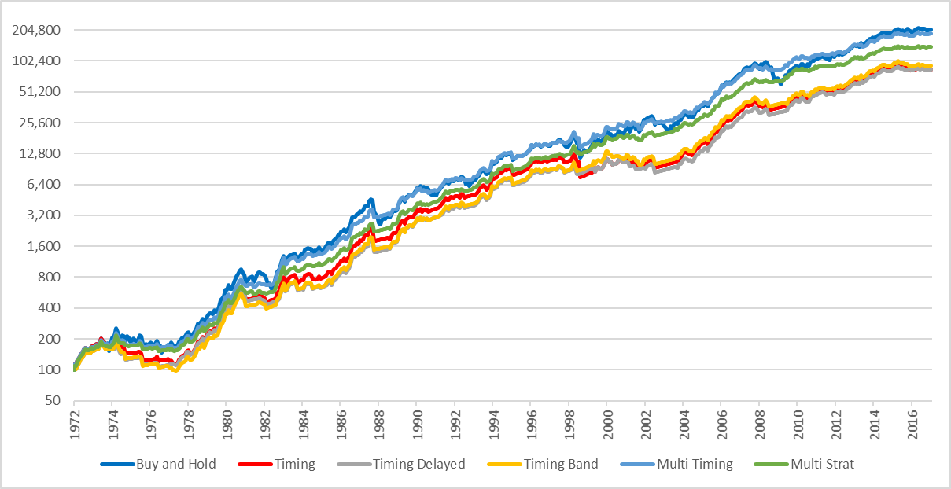

Figure 25 - JALSH Strategy Drawdowns 1972-2016, Non-log scale

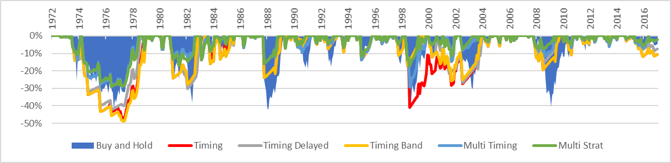

Table 19 - JALSH Strategy Performance Metrics 1972-2016

|  |  |  |  |  |  |  |
| --- | --- | --- | --- | --- | --- | --- |
|  | B&H | Timing | Timing Delayed | Timing Envelope | Multi Timing | Multi Strat |
| CAGR | 18.64% | 16.13% | 16.12% | 16.34% | 18.29% | 17.50% |
| Volatility | 20.99% | 17.26% | 15.96% | 16.48% | 14.90% | 13.36% |
| Skew | -0.45 | -0.66 | -0.32 | -0.28 | 0.01 | 0.20 |
| Kurtosis | 1.70 | 4.40 | 3.04 | 2.52 | 2.57 | 2.66 |
| Inflation CAGR | 9.48% | 9.48% | 9.48% | 9.48% | 9.48% | 9.48% |
| % in the Market | 100.00% | 75.42% | 69.32% | 73.75% | 69.38% | 62.88% |
| % positive Months | 61.92% | 71.53% | 74.12% | 71.90% | 69.87% | 71.16% |
| Best Month | 18.28% | 17.70% | 17.70% | 17.70% | 17.70% | 17.18% |
| Worst Month | -29.58% | -29.58% | -23.41% | -23.41% | -19.19% | -15.37% |
| Max Drawdown | -42.45% | -47.02% | -42.34% | -48.98% | -29.30% | -29.16% |
| Max Drawdown / CAGR | 2.28 | 2.91 | 2.63 | 3.00 | 1.60 | 1.67 |
| Sharpe Ratio (10.52%) | 0.34 | 0.30 | 0.32 | 0.32 | 0.47 | 0.47 |
| Sortino Ratio | 0.44 | 0.45 | 0.50 | 0.49 | 0.65 | 0.71 |
| MAR Ratio | 0.44 | 0.34 | 0.38 | 0.33 | 0.62 | 0.60 |
| Ulcer Index | 13.12 | 16.58 | 14.63 | 16.47 | 9.07 | 8.52 |

### MSCIWORLD – Foreign Developed Equities (in ZAR)

Figure 26 – MSCIWORLD (ZAR) Strategy Returns 1972-2016, Log Scale

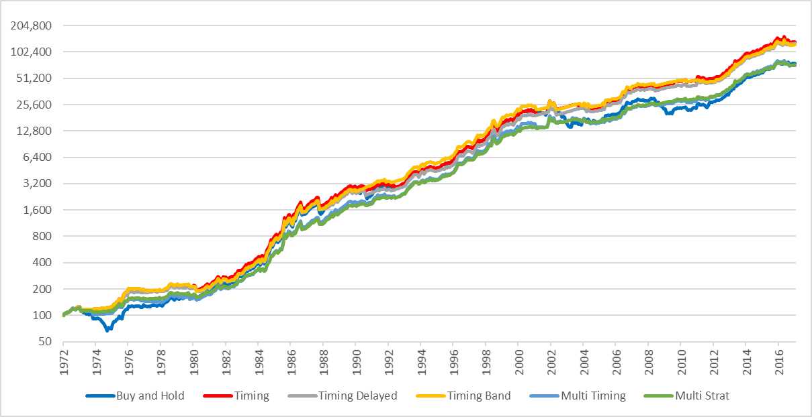

Figure 27 – MSCIWORLD (ZAR) Strategy Drawdowns 1972-2016, Non-log scale

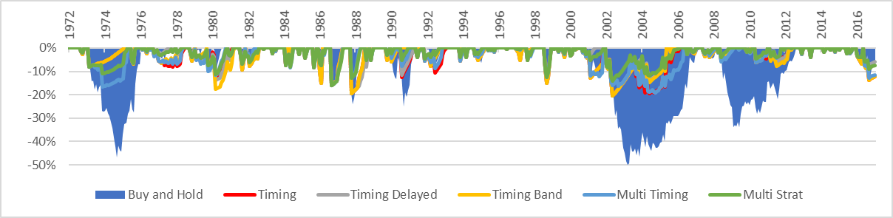

Table 20 – MSCIWORLD (ZAR) Strategy Performance Metrics 1972-2016

|  |  |  |  |  |  |  |
| --- | --- | --- | --- | --- | --- | --- |
|  | B&H | Timing | Timing Delayed | Timing Envelope | Multi Timing | Multi Strat |
| CAGR | 16.25% | 17.33% | 17.22% | 17.12% | 15.86% | 15.79% |
| Volatility | 17.57% | 15.07% | 14.55% | 14.62% | 13.53% | 12.28% |
| Skew | 0.40 | 0.69 | 0.78 | 0.74 | 0.88 | 1.14 |
| Kurtosis | 2.94 | 5.86 | 6.83 | 6.62 | 7.33 | 10.45 |
| Inflation CAGR | 9.48% | 9.48% | 9.48% | 9.48% | 9.48% | 9.48% |
| % in the Market | 100.00% | 77.45% | 71.90% | 73.20% | 70.92% | 61.72% |
| % positive Months | 62.85% | 73.57% | 75.79% | 75.60% | 71.72% | 74.49% |
| Best Month | 29.19% | 29.19% | 29.19% | 29.19% | 29.19% | 29.19% |
| Worst Month | -19.43% | -19.43% | -19.43% | -19.43% | -16.09% | -16.09% |
| Max Drawdown | -49.90% | -20.54% | -20.54% | -20.54% | -19.17% | -16.09% |
| Max Drawdown / CAGR | 3.07 | 1.19 | 1.19 | 1.20 | 1.21 | 1.02 |
| Sharpe Ratio (10.52%) | 0.28 | 0.41 | 0.42 | 0.41 | 0.35 | 0.39 |
| Sortino Ratio | 0.50 | 0.64 | 0.66 | 0.65 | 0.65 | 0.73 |
| MAR Ratio | 0.33 | 0.84 | 0.84 | 0.83 | 0.83 | 0.98 |
| Ulcer Index | 17.14 | 6.06 | 5.16 | 5.64 | 6.17 | 4.22 |

### SA10YR – Fixed Income

Figure 28 – SA10YR Strategy Returns 1972-2016, Log Scale

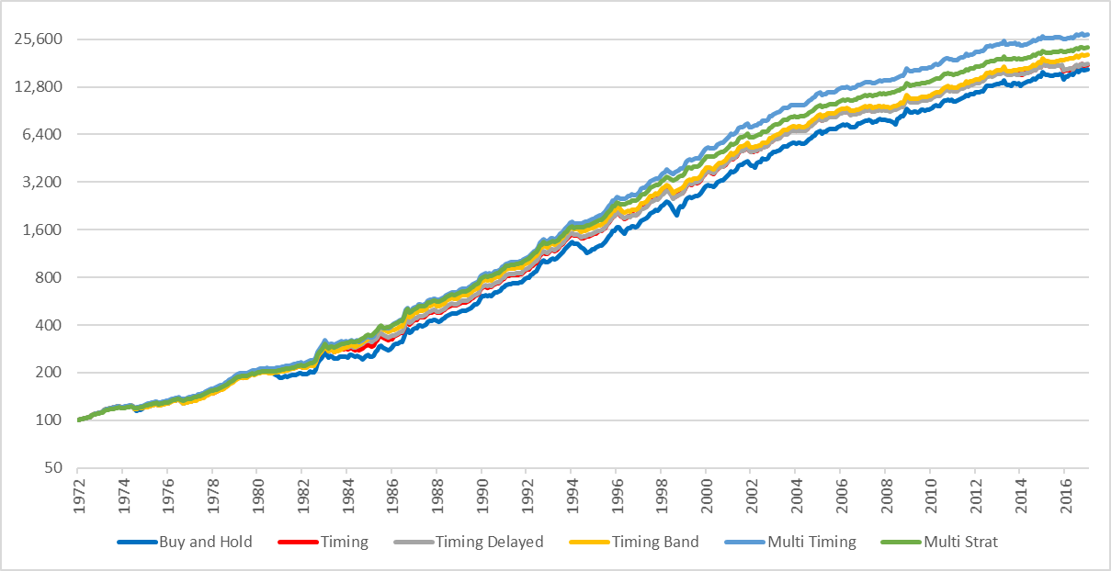

Figure 29 – SA10YR Strategy Drawdowns 1972-2016, Non-log scale

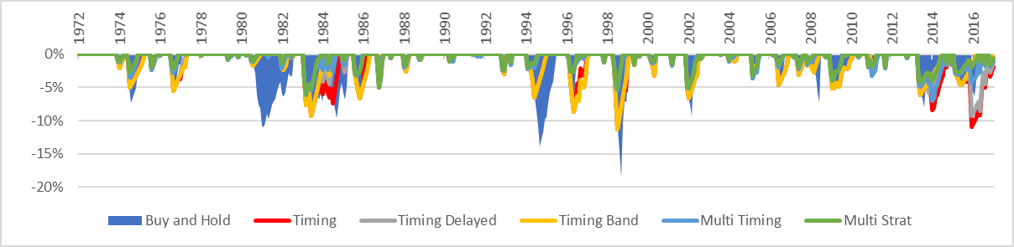

Table 21 – SA10YR Strategy Performance Metrics 1972-2016

|  |  |  |  |  |  |  |
| --- | --- | --- | --- | --- | --- | --- |
|  | B&H | Timing | Timing Delayed | Timing Band | Multi Timing | Multi Strat |
| CAGR | 12.00% | 12.19% | 12.20% | 12.53% | 13.28% | 12.80% |
| Volatility | 7.35% | 6.62% | 6.50% | 6.32% | 5.93% | 5.27% |
| Skew | 0.20 | 0.05 | 0.06 | 0.17 | 0.44 | 0.47 |
| Kurtosis | 1.82 | 2.21 | 2.48 | 2.48 | 2.71 | 3.64 |
| Inflation CAGR | 9.48% | 9.48% | 9.48% | 9.48% | 9.48% | 9.48% |
| % in the Market | 100.00% | 87.43% | 83.36% | 80.41% | 80.28% | 67.53% |
| % positive Months | 73.57% | 77.82% | 78.93% | 80.22% | 80.96% | 84.47% |
| Best Month | 10.14% | 9.09% | 9.09% | 9.09% | 9.09% | 9.09% |
| Worst Month | -6.67% | -6.67% | -6.67% | -5.14% | -5.03% | -5.03% |
| Max Drawdown | -18.63% | -11.35% | -11.35% | -11.35% | -7.06% | -6.14% |
| Max Drawdown / CAGR | 1.55 | 0.93 | 0.93 | 0.91 | 0.53 | 0.48 |
| Sharpe Ratio (10.52%) | 0.18 | 0.23 | 0.23 | 0.29 | 0.42 | 0.39 |
| Sortino Ratio | 0.94 | 1.05 | 1.07 | 1.17 | 1.49 | 1.66 |
| MAR Ratio | 0.64 | 1.07 | 1.07 | 1.10 | 1.88 | 2.08 |
| Ulcer Index | 3.47 | 2.70 | 2.51 | 2.28 | 1.48 | 1.21 |

### GSCI – Commodities (in ZAR)

Figure 30 – GSCI (ZAR) Strategy Returns 1972-2016, Log Scale

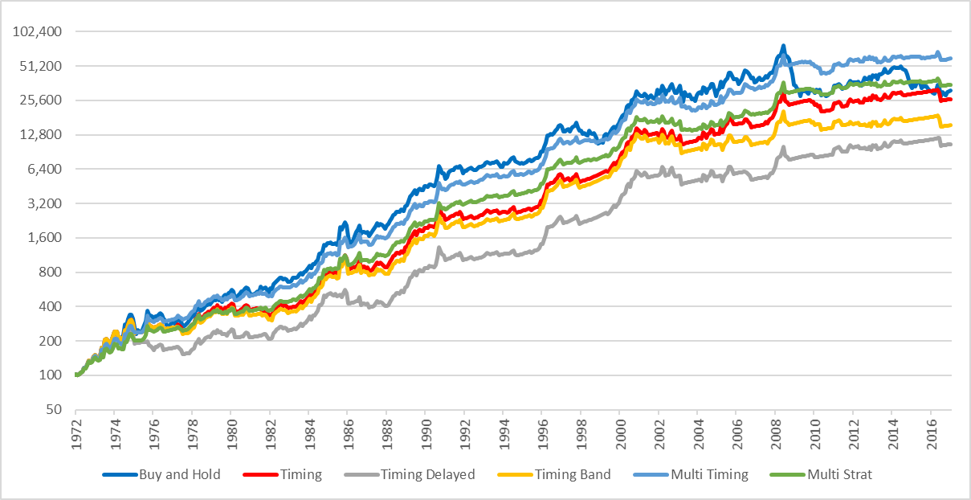

Figure 31 – GSCI (ZAR) Strategy Drawdowns 1972-2016, Non-log scale

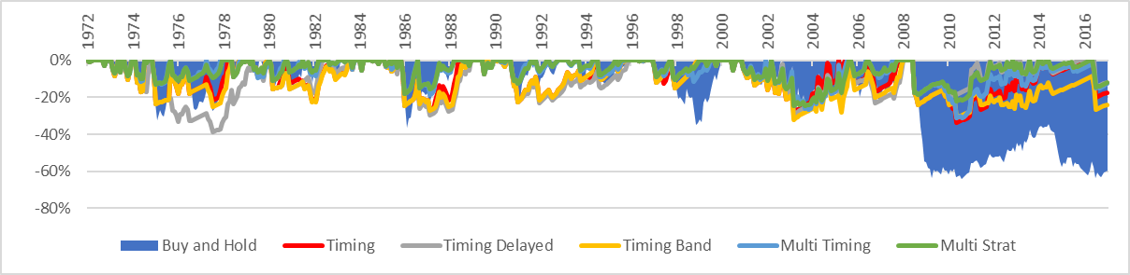

Table 22 – GSCI (ZAR) Strategy Performance Metrics 1972-2016

|  |  |  |  |  |  |  |
| --- | --- | --- | --- | --- | --- | --- |
|  | B&H | Timing | Timing Delayed | Timing Band | Multi Timing | Multi Strat |
| CAGR | 13.85% | 13.42% | 11.16% | 12.11% | 15.49% | 14.14% |
| Volatility | 22.91% | 19.04% | 17.38% | 18.75% | 17.11% | 15.22% |
| Skew | 0.21 | 0.59 | 0.20 | 0.63 | 0.88 | 0.51 |
| Kurtosis | 1.48 | 4.13 | 3.58 | 4.52 | 5.03 | 4.31 |
| Inflation CAGR | 9.48% | 9.48% | 9.48% | 9.48% | 9.48% | 9.48% |
| % in the Market | 100.00% | 69.32% | 62.29% | 65.62% | 64.94% | 56.48% |
| % positive Months | 59.89% | 72.46% | 74.68% | 73.38% | 70.24% | 71.90% |
| Best Month | 30.09% | 30.09% | 25.90% | 30.09% | 30.09% | 22.72% |
| Worst Month | -19.15% | -19.15% | -19.15% | -19.15% | -17.57% | -17.57% |
| Max Drawdown | -64.08% | -33.50% | -38.71% | -32.06% | -30.96% | -24.64% |
| Max Drawdown / CAGR | 4.63 | 2.50 | 3.47 | 2.65 | 2.00 | 1.74 |
| Sharpe Ratio (10.52%) | 0.12 | 0.13 | 0.02 | 0.06 | 0.25 | 0.20 |
| Sortino Ratio | 0.33 | 0.38 | 0.33 | 0.35 | 0.51 | 0.50 |
| MAR Ratio | 0.22 | 0.40 | 0.29 | 0.38 | 0.50 | 0.57 |
| Ulcer Index | 30.20 | 12.36 | 14.62 | 13.72 | 8.98 | 7.86 |

### Systematic Tactical Asset Allocation South Africa (1972-2016)

Figure 32 – Systematic Tactical Asset Allocation Strategy Returns 1972-2016, Log Scale

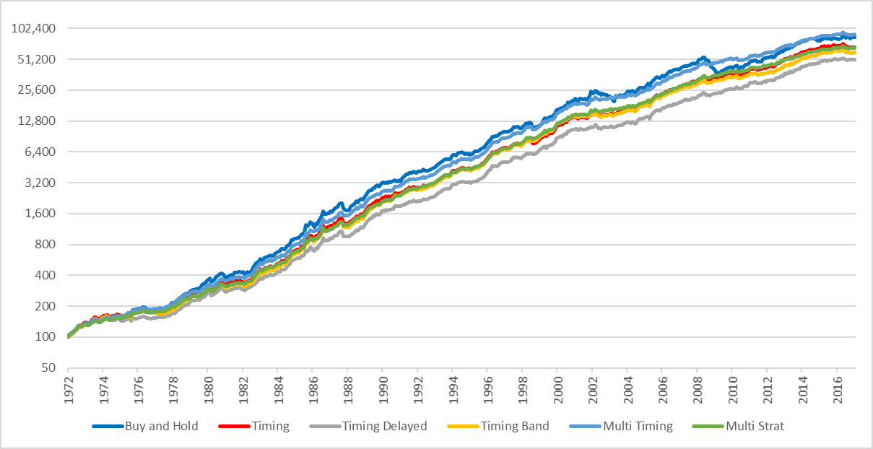

Figure 33 – Systematic Tactical Asset Allocation Strategy Drawdowns 1972-2016, Non-log scale

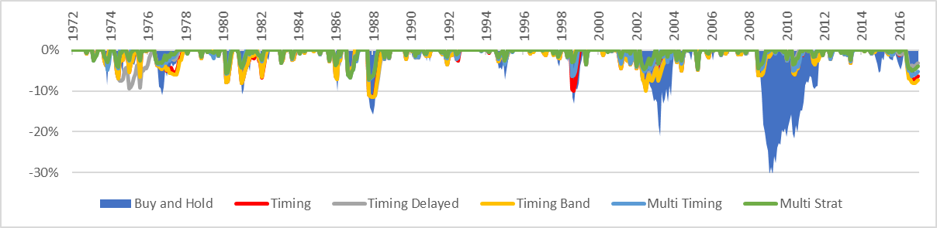

Table 23 – Systematic Tactical Asset Allocation Strategy Performance Metrics 1972-2016

|  |  |  |  |  |  |  |
| --- | --- | --- | --- | --- | --- | --- |
|  | B&H | Timing | Timing Delayed | Timing Band | Multi Timing | Multi Strat |
| CAGR | 16.36% | 15.63% | 14.92% | 15.32% | 16.39% | 15.59% |
| Volatility | 10.95% | 8.76% | 7.96% | 8.54% | 7.87% | 7.01% |
| Skew | 0.05 | 0.08 | -0.18 | 0.19 | 0.36 | 0.32 |
| Kurtosis | 1.74 | 3.96 | 2.52 | 4.14 | 3.36 | 3.31 |
| Inflation CAGR | 9.48% | 9.48% | 9.48% | 9.48% | 9.48% | 9.48% |
| % in the Market | 100.00% | 77.40% | 71.72% | 73.24% | 71.38% | 61.93% |
| % positive Months | 66.54% | 71.90% | 73.20% | 72.27% | 74.86% | 75.23% |
| Best Month | 16.34% | 16.34% | 10.33% | 16.34% | 15.11% | 12.71% |
| Worst Month | -10.98% | -10.98% | -10.98% | -10.98% | -7.29% | -7.15% |
| Max Drawdown | -30.61% | -11.59% | -11.59% | -11.59% | -7.29% | -7.15% |
| Max Drawdown / CAGR | 1.87 | 0.74 | 0.78 | 0.76 | 0.44 | 0.46 |
| Sharpe Ratio (10.52%) | 0.47 | 0.52 | 0.50 | 0.51 | 0.67 | 0.65 |
| Sortino Ratio | 0.83 | 1.01 | 1.07 | 1.04 | 1.32 | 1.45 |
| MAR Ratio | 0.53 | 1.35 | 1.29 | 1.32 | 2.25 | 2.18 |
| Ulcer Index | 6.35 | 2.60 | 2.58 | 2.60 | 1.74 | 1.47 |

When applied to the portfolio, the multi strategy again delivers superior performance to the buy and hold strategy and Faber’s original timing model. The multi strategy has the lowest volatility, maximum drawdown and ulcer index. Returning on average 15.59%p.a. and only suffering a drawdown of -7.15%, it seems to be a very attractive option for a risk adverse investor.

## South African Asset Class Returns including Real Estate (1993-2016)

Reliable data to represent South African Real Estate is available from 1993. Relooking at the 24-year period with a portfolio that includes real estate shows that over this period South African Real Estate has been the strongest performing asset class. Real Estate has the highest absolute and risk adjusted returns and over the period a Sharpe ratio of 0.54. Commodities again have the lowest absolute returns combined with the highest volatility. With the current drawdown, the annualised return since 1993 is just higher than inflation.

Figure 34 - South African Asset Class Returns 1993-2016, Log scale

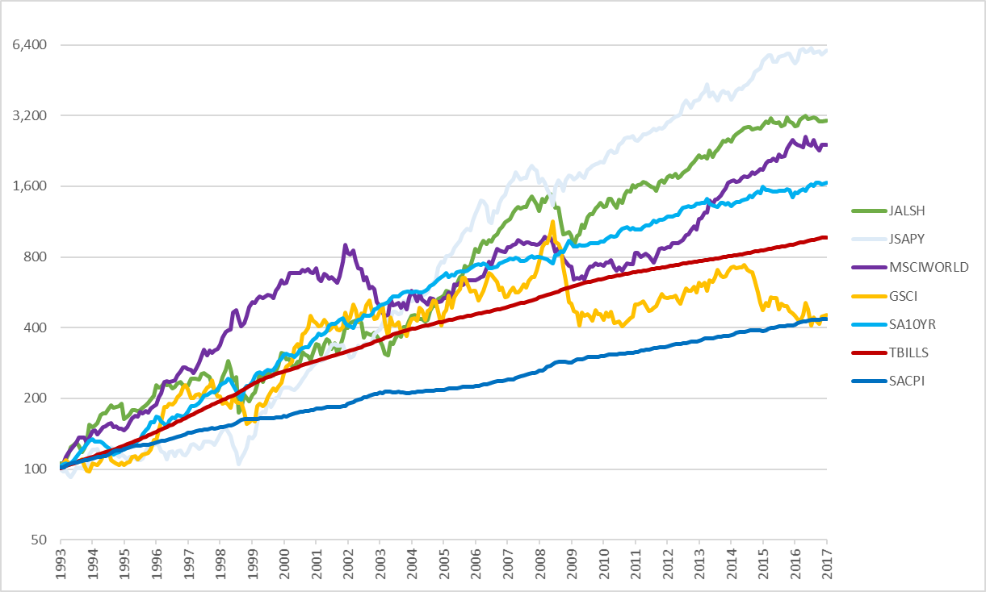

Table 24 - South African Asset Class Returns 1993-2016

|  |  |  |  |  |  |  |
| --- | --- | --- | --- | --- | --- | --- |
|  | TBILLS | JALSH | MSCIWORLD | SA10YR | GSCI | JASPY |
| Return | 9.84% | 14.59% | 13.54% | 11.74% | 6.85% | 19.40% |
| Volatility | 1.01% | 18.37% | 16.32% | 8.04% | 23.01% | 15.85% |
| Sharpe (9.84%) | -0.14 | 0.23 | 0.20 | 0.19 | -0.13 | 0.54 |
| MaxDD | 0.00% | -40.44% | -49.90% | -18.63% | -64.08% | -31.87% |
| Inflation CAGR | 6.19% | 6.19% | 6.19% | 6.19% | 6.19% | 6.19% |

### JSAPY – South African Real Estate

Figure 35 – JSAPY Strategy Returns 1994-2016, Log Scale

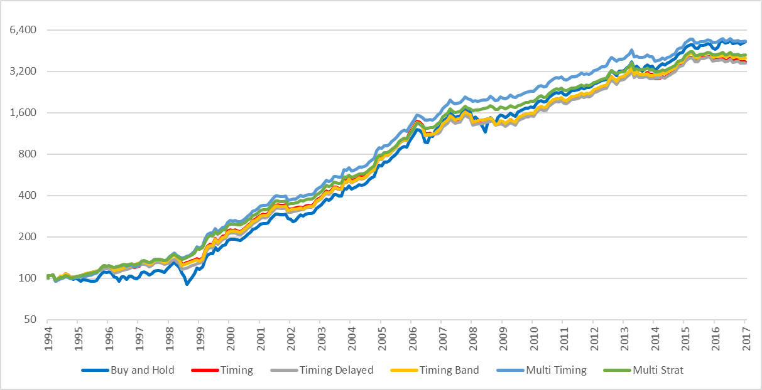

Figure 36 – JSAPY Strategy Drawdowns 1994-2016, Non-log scale

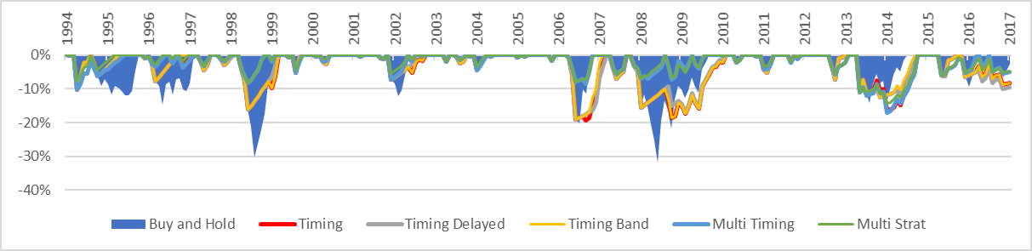

Table 25 – JSAPY Strategy Performance Metrics 1994-2016

|  |  |  |  |  |  |  |
| --- | --- | --- | --- | --- | --- | --- |
|  | B&H | Timing | Timing Delayed | Timing Band | Multi Timing | Multi Strat |
| CAGR | 19.40% | 17.71% | 17.60% | 18.02% | 19.24% | 17.93% |
| Volatility | 15.85% | 13.26% | 12.87% | 13.02% | 11.53% | 10.27% |
| Skew | -0.05 | -0.18 | -0.15 | -0.17 | 0.11 | 0.12 |
| Kurtosis | 1.15 | 2.35 | 2.86 | 2.62 | 2.01 | 2.14 |
| Inflation CAGR | 6.19% | 6.19% | 6.19% | 6.19% | 6.19% | 6.19% |
| % in the Market | 100.00% | 81.23% | 76.17% | 79.42% | 74.25% | 66.75% |
| % positive Months | 66.07% | 74.01% | 76.17% | 75.09% | 74.37% | 74.73% |
| Best Month | 18.19% | 14.52% | 14.52% | 14.52% | 13.45% | 13.42% |
| Worst Month | -13.93% | -13.93% | -13.93% | -13.93% | -11.09% | -11.09% |
| Max Drawdown | -31.87% | -19.25% | -19.00% | -19.00% | -17.02% | -14.34% |
| Max Drawdown / CAGR | 1.64 | 1.09 | 1.08 | 1.05 | 0.88 | 0.80 |
| Sharpe Ratio (9.84%) | 0.55 | 0.54 | 0.55 | 0.57 | 0.75 | 0.72 |
| Sortino Ratio | 0.64 | 0.67 | 0.69 | 0.70 | 0.94 | 1.00 |
| MAR Ratio | 0.61 | 0.92 | 0.93 | 0.95 | 1.13 | 1.25 |
| Ulcer Index | 7.15 | 6.41 | 6.14 | 6.13 | 4.04 | 3.64 |

### Systematic Tactical Asset Allocation South Africa including Real Estate (1994-2016)

Figure 37 – Systematic Tactical Asset Allocation Strategy Returns 1994-2016, Log Scale

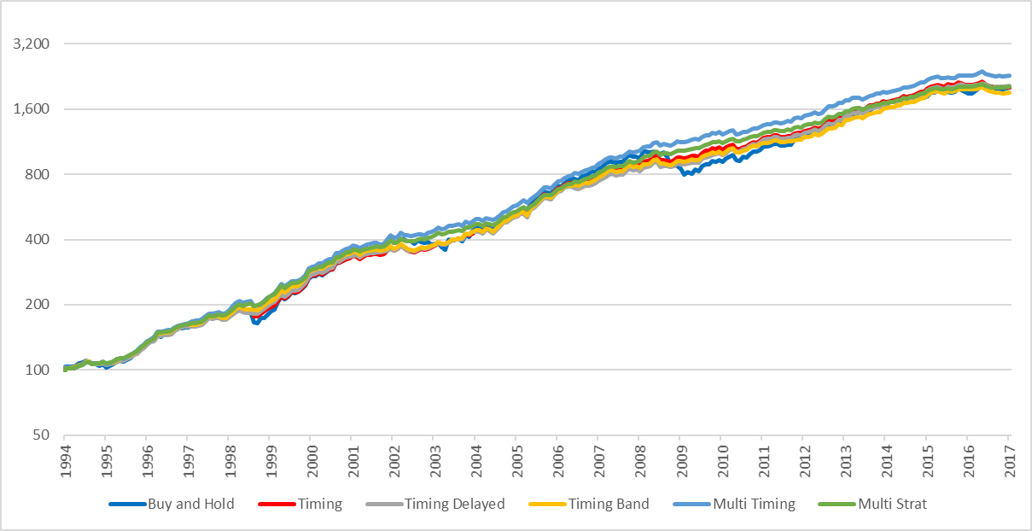

Figure 38 – Systematic Tactical Asset Allocation Strategy Drawdowns 1994-2016, Non-log scale

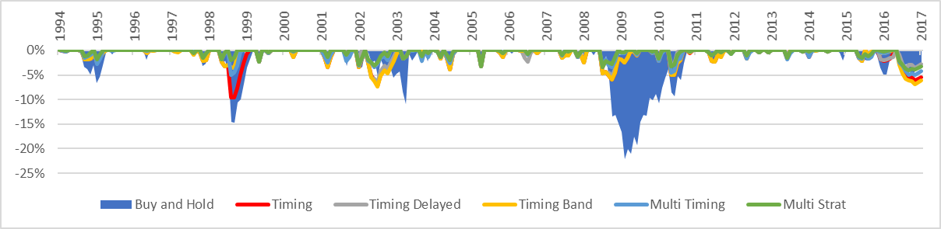

Table 26 – Systematic Tactical Asset Allocation Strategy Performance Metrics 1994-2016

|  |  |  |  |  |  |  |
| --- | --- | --- | --- | --- | --- | --- |
|  | B&H | Timing | Timing Delayed | Timing Band | Multi Timing | Multi Strat |
| CAGR | 14.28% | 14.30% | 14.35% | 14.03% | 14.85% | 14.20% |
| Volatility | 9.44% | 7.04% | 6.47% | 6.70% | 6.29% | 5.44% |
| Skew | -0.11 | 0.03 | 0.42 | 0.21 | -0.03 | 0.11 |
| Kurtosis | 1.88 | 1.31 | 1.25 | 1.00 | 0.84 | 0.86 |
| Inflation CAGR | 6.19% | 6.19% | 6.19% | 6.19% | 6.19% | 6.19% |
| % in the Market | 100.00% | 76.17% | 70.54% | 72.42% | 70.11% | 60.87% |
| % positive Months | 65.34% | 71.48% | 74.01% | 72.56% | 75.09% | 76.17% |
| Best Month | 11.52% | 8.42% | 8.42% | 8.42% | 7.16% | 6.83% |
| Worst Month | -10.90% | -6.72% | -4.69% | -4.92% | -4.81% | -3.40% |
| Max Drawdown | -22.19% | -9.59% | -6.51% | -7.41% | -5.05% | -4.08% |
| Max Drawdown / CAGR | 1.55 | 0.67 | 0.45 | 0.53 | 0.34 | 0.29 |
| Sharpe Ratio (9.84%) | 0.43 | 0.58 | 0.64 | 0.57 | 0.73 | 0.73 |
| Sortino Ratio | 0.84 | 1.27 | 1.60 | 1.39 | 1.55 | 1.89 |
| MAR Ratio | 0.64 | 1.49 | 2.21 | 1.89 | 2.94 | 3.48 |
| Ulcer Index | 4.66 | 1.95 | 1.42 | 1.76 | 1.24 | 0.94 |

Including real estate in the portfolio, the quantitative approach to asset allocation delivers far superior risk adjusted returns when compared to the buy and hold strategy and Faber’s original timing model. The multi strategy is invested in the market approximately 61% of the time and results in a reduction of volatility to mid-single digit levels of 5.44%, as well as a low-single digit maximum drawdown. The buy and hold portfolio’s maximum drawdown is reduced from 22.19% to 4.08% and the investor would need on average less than a third of a year to recover. As such the ulcer index is a low 0.94 and other risk adjusted metrics are all very attractive for a risk and loss adverse investor.

## Comparison to South African funds

Retail funds in South Africa are known as Collective Investment Schemes (CISs) and are regulated under the Collective Investment Schemes Control Act 2002 (CISCA). Funds are then categorised according to classifications specified by the Association for Savings and Investment South Africa (ASISA), an industry body which assists the Financial Services Board with the regulation of the industry. ASISA uses a three-tier classification system focusing on geographically where the fund will be invested (tier 1), what assets the fund invests in (tier 2) and then what the main focus of the fund will be (tier 3). One of the objectives of ASISA’s classification system is to facilitate the comparison of funds both across and within categories.

To compare the performance of the market timing strategy against comparative funds, the asset allocation has to be adjusted to fit within specific classification constraints. One potential fund classification that has similar risk and return objectives and requires only minor reweighting to the original equal weighted allocation is the South African - Multi Asset – Low Equity classification. These portfolios aim for long term capital growth and have a maximum of 40% equity and 25% property exposure. Based on the constraints set by ASISA and CISCA for this classification, the buy and hold, timing and multi strategy portfolios have been reweighted to 20% Domestic Equity, 20% Foreign Equity, 25% Fixed Income, 25% Property, 10% Commodities.

The comparative funds selected are the Allan Gray Stable Fund and the Prudential Inflation Plus Fund. These funds are two of the most popular and longest surviving South African – Multi Asset – Low Equity funds. Both were initiated in the early 2000s and provide 12 years of price history which allows for a comparison over the 2004-2016.

Without pricing in fees the performance of the multi strategy approach has superior risk adjusted performance across multiple performance metrics.

Table 27 - Fund Comparison Strategy Returns (0% fees)

|  |  |  |  |  |  |
| --- | --- | --- | --- | --- | --- |
|  | B&H | Timing | Multi Strat | Allan Gray Stable | Prudential Inflation Plus |
| CAGR | 14.15% | 13.30% | 12.61% | 11.43% | 12.76% |
| Volatility | 7.99% | 6.27% | 4.66% | 4.35% | 5.78% |
| Skew | -0.29 | 0.06 | -0.03 | 0.14 | -0.42 |
| Kurtosis | 0.69 | -0.01 | -0.40 | 0.71 | 0.66 |
| Inflation CAGR | 5.77% | 5.77% | 5.77% | 5.77% | 5.77% |
| % in the Market | 100.00% | 81.56% | 60.34% | 100.00% | 100.00% |
| % positive Months | 70.06% | 70.06% | 75.80% | 77.07% | 75.80% |
| Best Month | 6.95% | 6.95% | 4.38% | 4.66% | 5.43% |
| Worst Month | -6.71% | -3.99% | -2.79% | -3.30% | -4.51% |
| Max Drawdown | -16.77% | -4.80% | -2.79% | -4.10% | -8.59% |
| Max Drawdown / CAGR | 1.19 | 0.36 | 0.22 | 0.29 | 0.67 |
| Sharpe Ratio (7.22%) | 0.81 | 0.91 | 1.08 | 0.91 | 0.90 |
| Sortino Ratio | 1.00 | 1.44 | 2.15 | 2.05 | 1.30 |
| MAR Ratio | 0.84 | 2.77 | 4.52 | 3.46 | 1.49 |
| Ulcer Index | 3.48 | 1.36 | 0.71 | 0.61 | 1.51 |

However both the returns of Allan Gray Stable Fund and Prudential Inflation Plus Fund are after 0.80% to 1.60% annual management fees, performance fees and other costs. Conservatively pricing in 1.00% p.a. to cover trading fees, slippage and other costs impacts the performance slightly and provides a more realistic comparison.

Figure 39 - Fund Comparison Strategy Returns 2004-2016

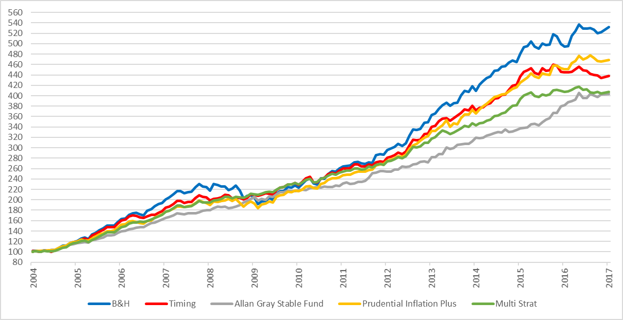

Table 28 - Fund Comparison Strategy Returns (1%. fees) 2004-2016

|  |  |  |  |  |  |
| --- | --- | --- | --- | --- | --- |
|  | B&H | Timing | Multi Strat | Allan Gray Stable | Prudential Inflation Plus |
| CAGR | 14.15% | 12.19% | 11.50% | 11.43% | 12.76% |
| Volatility | 7.99% | 6.27% | 4.66% | 4.35% | 5.78% |
| Skew | -0.29 | 0.06 | -0.03 | 0.14 | -0.42 |
| Kurtosis | 0.69 | -0.01 | -0.40 | 0.71 | 0.66 |
| Inflation CAGR | 5.77% | 5.77% | 5.77% | 5.77% | 5.77% |
| % in the Market | 100.00% | 81.56% | 60.34% | 100.00% | 100.00% |
| % positive Months | 70.06% | 70.06% | 74.52% | 77.07% | 75.80% |
| Best Month | 6.95% | 6.87% | 4.29% | 4.66% | 5.43% |
| Worst Month | -6.71% | -4.08% | -2.87% | -3.30% | -4.51% |
| Max Drawdown | -16.77% | -5.41% | -2.99% | -4.10% | -8.59% |
| Max Drawdown / CAGR | 1.19 | 0.44 | 0.26 | 0.29 | 0.67 |
| Sharpe Ratio (7.22%) | 0.81 | 0.74 | 0.86 | 0.91 | 0.90 |
| Sortino Ratio | 1.00 | 1.27 | 1.85 | 2.05 | 1.30 |
| MAR Ratio | 0.84 | 2.25 | 3.85 | 3.46 | 1.49 |
| Ulcer Index | 3.48 | 1.56 | 0.80 | 0.61 | 1.51 |

After adjusting the multi strategy for trading costs it still delivers competitive risk adjusted performance compared to the actual funds. For absolute returns, the buy and hold strategy delivers the highest returns but also the highest volatility and largest maximum drawdown. The multi strategy approach delivers total returns in line with the two comparison funds, has the lowest maximum drawdown of 2.99% and is either best or second best ranked in all risk adjusted performance metrics. With a max drawdown / CAGR ratio of 0.26, it implies that on average the investor will need just over a quarter of a year’s returns to recover from any drawdown which is exceptionally attractive for a loss adverse investor.

Overall the multi strategy provides the investor an attractive alternative for investing in the South Africa – Multi Asset – Low Equity classification especially if the investor is able to keep trading costs and fees below 1.00% per annum. It worth acknowledging that the multi strategy’s performance would be even more attractive if it were compared to all other funds that have existed in this classification. For the purpose of keeping it simple and to enable the longest period of comparison, the two longest surviving and most successful funds were chosen. However if we were to compare to the performance of the average peer in the classification, including funds that have not survived over this period, the performance would make the multi strategy even more attractive.

# Conclusion

The purpose of this paper was to replicate, analyse and extend Mebane Faber’s A Quantitative Approach to Asset Allocation before applying the model and any improvements to a South African asset allocation. The paper has identified the drivers behind the performance, the behavioural implications for investors following the strategy as well as looked at improving returns via asset and strategy diversification. Lastly, the paper applies the approach to an asset allocation relevant to a South Africa investor and compares performance to two of the most successful and popular funds.

Updating Faber’s model and reviewing the last 10 years of performance since his research paper was first released shows a small deterioration in absolute returns for both the buy and hold and timing model multi asset portfolios. The timing model however performed as designed and exceled during in the 2007-2008 global financial crisis, removing exposure to assets as they went into drawdown. The timing model limited portfolio drawdowns to 9.22%, significantly better than the 46.10% drawdown witnessed by the buy and hold portfolio.

Researching the quantitative approach found performance to be driven by diversification and the trend following strategy overlay. Despite a wealth of research supporting the rules based strategy, ultimately success required an investor overcoming cognitive biases and having enough discipline to stick with the mechanical rules based strategy.

The paper then investigated ideas to improve Faber’s original timing signal and provided evidence that combining strategy parameters and trend following strategies can generate significant improvement in risk adjusted performance. Compared to the buy and hold portfolio and original timing model, the multi strategy delivers performance that would be very attractive to a risk and/or loss adverse investor. Absolute returns were comparable but with significantly less volatility and drawdowns.

Applying the buy and hold, timing and multi strategy to an asset allocation more relevant to a South African investor showed consistent results. Faber’s timing model delivered superior risk adjusted returns to the buy and hold portfolio with drawdowns reduced by approximately 50-66%. The multi strategy improved the performance, delivering absolute returns in line with the buy and hold strategy but with just over half the volatility. The maximum drawdowns on the multi strategy was an impressive 4.08%, a fifth of the maximum drawdown of the comparable buy and hold portfolio.

Changing the asset allocation to fit within certain South African Fund classification constraints, the strategy performance was recalculated to then compare against two of the most popular funds. Despite being penalised by survivorship bias, the multi strategy timing model delivered comparable absolute returns and overall showed superior risk adjusted performance for a loss adverse investor. With conservative margin priced in to cover trading fees, cost and slippage, there is additional room for improvement if the investor is able to find a low cost way to implement the strategy.

Overall this paper shows that strategy level diversification may offer substantial long term value especially by reducing drawdowns. The improved multi strategy approach on its own produces strong risk adjusted returns compared to both the buy and hold strategy and the original timing strategy. Crucially for loss adverse investors the multi strategy approach significantly reduces the maximum drawdowns which may have important implications for those investors. Investors nearing retirement are generally advised to sacrifice potential higher returns from higher risk asset classes and shift their asset allocation towards low risk asset classes such as cash or fixed income bonds. The multi strategy approach gives investors another alternative, where they can still gain equity like absolute returns while being protected from drawdowns from using trend following timing strategies.

# Appendix – Review of R

One of the goals of this masters was to learn a new programming language R. R is an open source language widely used by data scientists for analysis in a wide variety of fields. Initiated in 1997, R has grown in popularity along with an ever increasing number of packages available that extend the base R functions.

My experience using R over the last 9 months has been mixed. Despite being relatively fluent in other programming languages and generally very competent with computers, R proved to have a very steep learning curve. Supported of R say this is an unavoidable byproduct of the languages power and flexibility however it is also related to the minimal graphical user interface and requirement to enter everything via command line. Based around S, a language written in 1970, R can be clunky and difficult to use and is code based unless you install a third party GUI. Multiple hours were spent installing R, RStudio and learning the basics and understanding the general workflow. Installing packages especially on computers with strict proxies and firewalls also soaked up time.

R has many advantages; it’s free, powerful for data analysis, open source and supported online by a large active user base. Unfortunately, one of the drawbacks to this is that support can be slow and finding solutions or debugging code can be frustrating. Support was found from a variety of sources – online forums, mailing lists, IRC chats as simply searching the internet to find solutions on sites such as stackoverflow.

One of the biggest strengths of working with R was packages. Packages are user created bundles of code, that add specialist functions to the base R code. For example all performance metrics in the report was the result of one package, with many metrics requiring a simple line of code identifying returns to calculate CAGRs, Sharpe Ratios, and max drawdowns. A summary of the packages used can be found below.

One issue I found with using packages is that updates can occur and remove previous functionality. For example the package performanceanalytics, which provides several functions for analysing portfolio performance, updated it graphs to use xyz. This resulted in several charts no longer displaying as originally designed, with simple things such as date formats no longer working to more critical things such as being unable to display on a log y axis.

There are a variety of courses available online from coursera, datacamp as well as a book R4DS that I would recommend for anyone interested in exploring R further.

Packages used:

|  |  |
| --- | --- |
| PerformanceAnalytics | Collection of econometric functions for performance and risk analysis |
| Quantmod | Charting, downloading of data from FRED, yahoo finance. |
| Quantstrat | Functions for building trading strategies |
| Dplyr / Tidyverse |  |
| Rblpapi |  |
|  |  |
|  |  |

# References

Antonacci, G. (2017). *Are Commodities Still a Good Portfolio Diversifier?* Retrieved Jan 2017, from http://www.dualmomentum.net/2017/01/are-commodities-still-good-portfolio.html

Bacon, C. (2004). *Practical Portfolio Performance Measurement and Attribution.*

Bhardwaj, G., Gorton, G., & Rouwenhorst, G. (2015). *Facts and Fantasies About Commodity Futures Ten Years Later.*

Black, F., & Scholes, M. (1973). From Theory to a New Financial Product. *The Journal of Finance, 29*(2), 399-412.

Cheung, S., & Miu, P. (2010). Diversification benefits of commodity futures. *Journal of International Financial Markets, Institutions & Money*, 451-474.

Cilella, S. (2015, February 20). *Why It Pays To Diversify Your Trading Strategies*. Retrieved from See It Market: https://www.seeitmarket.com/pays-diversify-trading-strategies-14127/

Clare, A., Seaton, J., Smith, P., & Thomas, S. (2012). *The Trend is Our Friend: Risk Parity, Momentum and Trend Following in Global Asset Allocation.*

Clenow, A. (2013). *Following the Trend.*

Clenow, A. F. (2015). *Stocks on the Move: Beating the Market with Hedge Fund Momentum Strategies.*

Covel, M. W. (2013). *Trend Following.*

Domanski, D., & Heath, A. (2007). Financial Investors and Commodity Markets. *BIS Quarterly Review*(March), 53-67.

Erb, C. B., & Harvey, C. R. (2006). The Strategic and Tactical Value of Commodity Futures. *Financial Analysts Journal, 62*, 69-97.

Faber, M. (2007). A Quantitative Approach to Tactical Asset Allocation. *The Journal of Wealth Management*(Spring), 69-79.

Faber, M. (2009). *A Quantitative Approach To Tactical Asset Allocation.*

Faber, M. (2013). *A Quantitative Approach to Tactical Asset Allocation.*

Faber, M., & Richardson, E. (2009). *The Ivy Portfolio: How to Invest Like the Top Endowments and Avoid Bear Markets.*

Firer, C., & McLeod, H. (1999). Equities, bonds, cash and inflation : Historical performance in South Africa 1925-1998. *Investment Analysts Journal*, 7-28.

Garnry, P. (2016, February 18). *Trading strategies: No need for the holy grail*. Retrieved from Predictive Alpha: https://predictivealpha.wordpress.com/2016/02/16/trading-strategies-no-need-for-the-holy-grail-2/

Gorton, G., & Rouwenhorst, K. (2004). Facts and Fantasies about Commodity Futures. *Yale ICF Working Paper No. 04-20*.

Gray, W. (2016). *Alpha Architect - Even God Would Get Fired As An Active Investor*. Retrieved from http://blog.alphaarchitect.com/2016/02/02/even-god-would-get-fired-as-an-active-investor/

Greer, R. (1997). What is an Asset Class, Anyway? *The Journal of Portfolio Management, 23*, 86-91.

Greyserman, A., & Kaminski, K. (2014). *Trend Following with Managed Futures: The Search for Crisis Alpha.*

Ibbotson Associates. (2006). *Strategic Asset Allocation and Commodities.* PIMCO.

Ibbotson et all. (2016). *Stocks, Bonds, Bills and Inflation (SBBI) Yearbook.*

Ilmanen, A. (2011). *Expected Returns: An Investor's Guide to Harvesting Market Rewards.*

Irwin, S., & Sanders, D. (2010). *The Impact of Index and Swap Funds on Commodity Futures Markets: Preliminary Results.* OECD Food, Agriculture and Fisheries Working Papers, No. 27.

Jennings, W. W., & Payne, B. C. (2016). Fees Eat Diversification Lunch. *Financial Analysts Journal, 72*(2), 31-40.

Levine, A., Ooi, Y., & Richardson, M. (2016). Commodities for the Long Run.

Lombardi, M., & Ravazzolo, F. (2013). On the correlation between commodity and equity returns: implications for portfolio allocation. *Bank for International Settlements Working Papers, 420*.

Markowitz, H. (1952). Portfolio Selection. *The Journal of Finance, 7*(1), 77-91.

Martin, P. G., & McCann, B. B. (1989). *The Investor's Guide to Fidelity Funds.*

Morningstar. (2008). Return Calculation of U.S. Treasury Constant Maturity Indices.

Sandoval Jr, L., & Franca, I. (2010). *Correlation of financial markets in times of crisis.*

Silvennoinen, A., & Thorp, S. (2009). *Financialization, crisis and commodity correlation dynamics.*

Tversky, A., & Kahneman, D. (1971). Belief in the law of small numbers. *Psychological Bulletin, 76*, 105-110.

Zaremba, A. (2015). Portfolio Diversification with Commodities in Times of Financialization. *International Joural of Finance & Banking Studies, 4*(1), 18-36.

Faber, Meb (2006). A Quantitative Approach to Tactical Asset Allocation (working paper).

Statistical Mechanics and its Applications, 391, 1, p 187-208

Inker, B., (2020). “The Hidden Risks of Risk Parity Portfolios”, GMO White Paper

Friesen, G., Weller, P. and L. Dunham, (2009), “Price trends and patterns in technical analysis: A theoretical and empirical examination”, Journal of Banking & Finance, 33, 1089- 1100.